
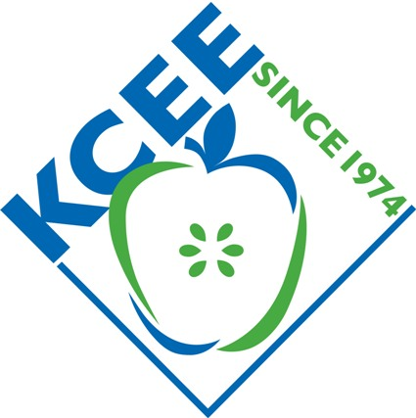

Winners for Spring 2013
Take Stock in Kentucky

Take Stock in Kentucky State Winning Teams
State Rank | Team ID | % Return  Above/Below  S&P 500 Growth |  |  | Portfolio Value |  | School |  | Teacher
1 | ZZ28 | 4.0077 |  |  | $108,964 |  | MADISON SOUTHERN HIGH SCHOOL |  | Allen, Jennifer
2 | ZZ112 | 3.7697 |  |  | $108,726 |  | ST. GABRIEL SCHOOL |  | Owens, Theresa
Regional Winning Teams
Regional  Rankings |  |  | Team ID | % Return  Above/  Below  S&P 500 Growth |  | Portfolio Value |  | School |  | Teacher
Central Elem/MS |  |  | ZZ112 | 3.7697 |  | $108,726 |  | ST. GABRIEL SCHOOL |  | Owens, Theresa
Central HS |  |  | ZZ28 | 4.0077 |  | $108,964 |  | MADISON SOUTHERN HIGH SCHOOL |  | Allen, Jennifer
East Elem/MS |  |  | ZZ101 | (0.5077) |  | $104,449 |  | ESTILL SPRINGS ELEMENTARY SCHOOL |  | Samples, Shiela
North Elem/MS |  |  | A4 | (4.4297) |  | $101,791 |  | BURLINGTON ELEMENTARY SCHOOL |  | Brake, Jayna
West Elem/MS |  |  | ZZ88 | (2.2028) |  | $102,754 |  | STURGIS ELEMENTARY SCHOOL |  | Duffy, Jennifer

Congratulations to all the teams participating!!

Take Stock in Kentucky awards include: 1st place prize of $300 for team, 2nd place of $100 for team. Teams will also receive school trophies, Take Stock in KY t-shirts, and team members will receive certificates. Regional Award first place teams will all receive certificates and Take Stock in KY t-shirts. All State and Regional winning team members are invited to the Stock Market Game Awards Banquet, hosted by Hilliard Lyons and the Federal Reserve Bank of St. Louis-Louisville Branch, at the Louisville Pendennis Club, on May 22 to be recognized.

The Stock Market Game™ is a national program of the Foundation for Investor Education and is offered in Kentucky by the Kentucky Council on Economic Education (KCEE). It is an interactive, interdisciplinary program for students in grades 4-12 (and college) to learn about economics, finance, and our American economic system. The program is offered each Fall and Spring. Over a period of 10 weeks, teams of students research companies, make investment decisions, and create their portfolios, investing $100,000 in imaginary money in stocks and mutual funds. Teams are ranked on equity in portfolio. Teachers are provided with educational resources to teach students about investing, capital formation, the stock market, and the economy. Student teams compete against other Kentucky teams statewide and across local regions for prizes. In the Take Stock in Kentucky, students research stocks for their portfolio from a group of 200 companies that are headquartered in Kentucky, or have high presence, i.e., large employers, large number of stores, etc. They learn about the state economy and local business.

"They see that the concepts we're learning have real-life applications. Making those connections makes them more eager to learn." Kentucky teacher

“Keeping up with their portfolios enabled (my students) to practice math skills and learn some valuable information about business. I have no doubt their math, social studies, and practical living skills were in enhanced through this program! Kentucky Teacher

For more info, contact the Kentucky Council on Economic Education, 502-267-3570 or info@econ.org.

Take Stock in Kentucky and the Stock Market Game are sponsored by Hilliard Lyons.
www.econ.org/smg

