
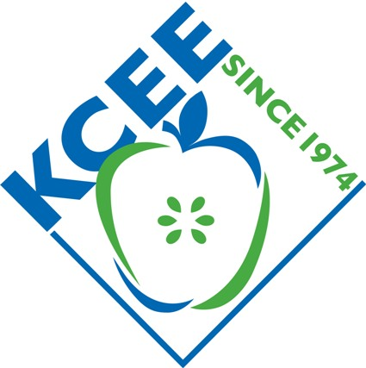

Winners for Fall 2014
Take Stock in Kentucky
Stock Market Game Competition

CONGRATULATIONS TO BARDSTOWN MIDDLE SCHOOL for having THE FIRST PLACE team in the –Take Stock In Kentucky competition! Team REEF, KY-32-ZZ17 came in first place with a portfolio value of $113,250. Second place went to Reidland Elementary Middle School (Karla Lindsey, teacher), and third place to Holy Family School (Mark Worthington, teacher).
We hope all the teams participating had a great experience with Take Stock in Kentucky—that they learned something about the importance of investing early, doing their research, “buy what you know”, and the buy and hold strategy!

Thanks for joining us and we look forward to next year’s sessions!!

Rank | Team ID | % Return  Above/Below  S&P 500 Growth | Total Equity | School / Organization | Advisor
1 | KY_32_ZZ17 | 11.5012 | $113,250 | Bardstown Middle School | Dawn Greenwell
2 | KY_32_ZZ37 | 4.7198 | $106,469 | Reidland Elementary School | Karla Lindsey
3 | KY_32_ZZ75 | (0.8316) | $104,215 | Holy Family School | Mark Worthington

For the Take Stock in Kentucky, 70 teams, 15 teachers, and 297 students participated in this competition.

Congratulations to all the teams participating!!

Awards:
- First Place in State Team winners will receive $50 gift cards, certificates, and trophy for school/class
- Second Place in State Team winners will receive $20 gift cards, and certificates
- Third in State Team winners will receive medals and certificates.

The Stock Market Game™ is a national program of the Foundation for Investor Education and is offered in Kentucky by the Kentucky Council on Economic Education (KCEE). It is an interactive, interdisciplinary program for students in grades 4-12 (and college) to learn about economics, finance, and our American economic system. The program is offered each Fall and Spring. Over a period of 10 weeks, teams of students research companies, make investment decisions, and create their portfolios, investing $100,000 in imaginary money in stocks and mutual funds. Teams are ranked on equity in portfolio. Teachers are provided with educational resources to teach students about investing, capital formation, the stock market, and the economy. Student teams compete against other Kentucky teams statewide and across local regions for prizes.

"They see that the concepts we're learning have real-life applications. Making those connections makes them more eager to learn." Kim Code, teacher

“Keeping up with their portfolios enabled (my students) to practice math skills and learn some valuable information about business. I have no doubt their math, social studies, and practical living skills were all enhanced through this program! Traci Gillock, Teacher

For more info, contact the Kentucky Council on Economic Education, 502-272-8707 or susan@econ.org.

About the KCEE: The Kentucky Council on Economic Education is a 40 year old non-profit organization that provides professional development opportunities for Kentucky teachers, classroom curricula and resources, and programs, like the Stock Market Game and Take Stock in Kentucky. Since 1974, KCEE has worked with tens of thousands of committed teachers through our six Centers at Morehead, Murray State, Eastern Kentucky, Western Kentucky, Northern Kentucky and Bellarmine Universities.

