
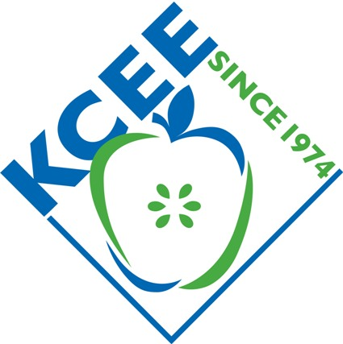

Winners for Spring 2013
Late Spring Session
Stock Market Game Competition

State Winning Teams
State Rank | Team ID | % Return  Above/Below  S&P 500 Growth | Portfolio Value | School | Teacher
1st | ZZ101 | 5.23 | $109,300 | JESSIE M. CLARK MIDDLE SCH. | Che Farris
2nd | ZZ72 | 3.40 | $107,468 | EWING ELEMENTARY SCHOOL | Gwendolyn Hargett

Stock Market Game awards include: 1st place prize of $300 for team, 2nd place of $100 for team. Teams will also receive school trophies, SMG t-shirts, and member certificates. Regional Award first place teams will all receive certificates and SMG t-shirts. All State and Regional winning team members are invited to the Kentucky Council on Economic Education Awards Luncheon, at the Louisville Pendennis Club, on May 22 to be recognized and receive awards.

The Stock Market Game™ is a national program of the Foundation for Investor Education and is offered in Kentucky by the Kentucky Council on Economic Education (KCEE). It is an interactive, interdisciplinary program for students in grades 4-12 (and college) to learn about economics, finance, and our American economic system. The program is offered each Fall and Spring. Over a period of 10 weeks, teams of students research companies, make investment decisions, and create their portfolios, investing $100,000 in imaginary money in stocks and mutual funds. Teams are ranked on equity in portfolio. Teachers are provided with educational resources to teach students about investing, capital formation, the stock market, and the economy. Student teams compete against other Kentucky teams statewide and across local regions for prizes.

"They see that the concepts we're learning have real-life applications. Making those connections makes them more eager to learn." Kim Code, teacher

“Keeping up with their portfolios enabled (my students) to practice math skills and learn some valuable information about business. I have no doubt their math, social studies, and practical living skills were all enhanced through this program! Traci Gillock, Teacher

For more info, contact the Kentucky Council on Economic Education, 502-267-3570 or info@econ.org.

About the KCEE: The Kentucky Council on Economic Education is a 38 year old non-profit organization that provides professional development opportunities for Kentucky teachers, classroom curricula and resources, and programs, like the Stock Market Game and Take Stock in Kentucky. Since 1974, KCEE has worked with tens of thousands of committed teachers through our six Centers at Morehead, Murray State, Eastern Kentucky, Western Kentucky, Northern Kentucky and Bellarmine Universities. Last year alone, we trained over 1,900 teachers through our professional development offerings and many more used our programs. We are also hosting our 4th annual Life Fundamental$ Financial Literacy Summit this summer (June 23-24) for middle and high school educators.

Thanks to our Statewide sponsor


