
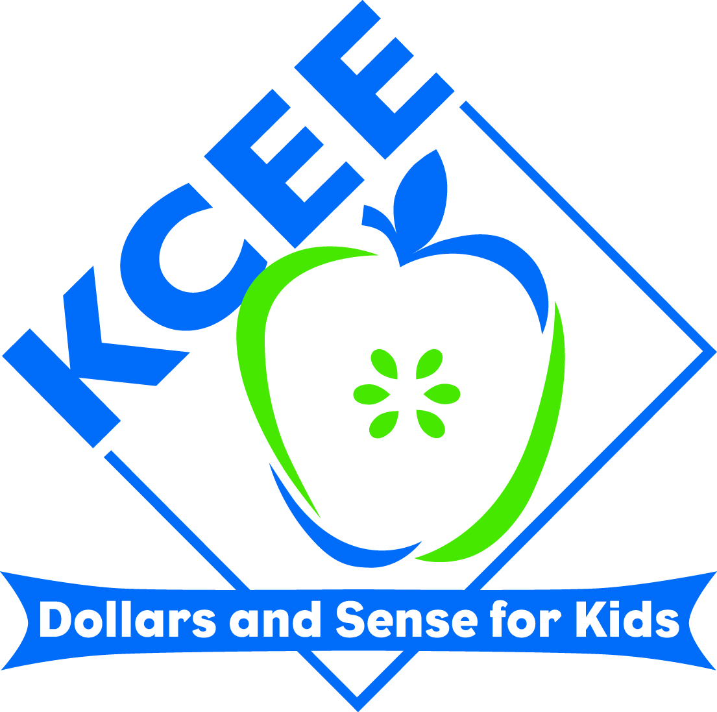
KCEE ECONOMICS/FINANCIAL LITERACY
LESSONS

Lesson Title: Triangular Slave Trade and Rice Krispies

Subject: Economics with a focus on the interdependency involved in the triangular slave trade to acquire natural, human, and capital resources.

Grade Range: 4th – 6th Grade

Your name: Laureen Laumeyer
Email address: llaumeyer@comcast.net or laureen.laumeyer@hardin.kyschools.us
School District: Hardin County Schools
School Name and Address: Woodland Elementary
6000 Woodland Drive
Radcliff, KY 40160

Description: This lesson is designed to provide students with a hands-on opportunity to experience the trading process involved in the Triangular Slave Trade. My 5th graders have a difficult time understanding that slavery is/was an economic situation. This lesson is more of a hook to understand the interdependency between Europe, Africa, and the Americas to meet their needs of human, capital, and natural resources.

The students are challenged to get enough supplies necessary to make Rice Krispie Bars. However, the students are divided into three (3) groups. Each group is in control of certain items necessary to the production of the Rice Krispie Bars. Europe has the capital resource tools (bowls, measuring spoons, etc.), American has the natural resources (butter, Rice Krispies, Marshmallows, etc.), and Africa has the human resources (the chefs). The groups have to trade to meet their needs.

The conclusion of the lesson/hook allows the students to see that they were willing to trade their classmates in order to make Rice Krispie Bars. The groups were interdependent upon each other just as Europe, Africa, and the America were interdependent upon each other to meet their needs.

This lesson provided a spring board for me into our unit on Slavery. The students began to see that slavery was a very complicated issue because of its influence of the economy of the time.

Duration: It took approximately 50 minutes to complete.

Standards:
SS - 05:3.4.3 DOK 3
Students will define interdependence and give examples of how people in our communities, states, nations, and world depend on each other for goods and services.

SS – 05:2.3.1
Students will describe various forms of interactions (compromise, cooperation, conflict) that occurred between Europeans, Africans, and Americans in the history of the United States

SS-05-3.1.1 DOK 2
Students will describe scarcity and explain how scarcity required people in different periods in the U.S. (Colonization, Expansion, Twentieth Century to Present) to make economic choices (e.g., use of productive resources- natural, human, capital) and incur opportunity costs

Lesson:
Triangular Slave Trade and Rice Krispies

Core Content:
SS - 05:3.4.3 DOK 3
Students will define interdependence and give examples of how people in our communities, states, nations, and world depend on each other for goods and services.

SS – 05:2.3.1
Students will describe various forms of interactions (compromise, cooperation, conflict) that occurred between Europeans, Africans, and Americans in the history of the United States

SS-05-3.1.1 DOK 2
Students will describe scarcity and explain how scarcity required people in different periods in the U.S. (Colonization, Expansion, Twentieth Century to Present) to make economic choices (e.g., use of productive resources- natural, human, capital) and incur opportunity costs.

Essential Question:
How do countries get the goods and services they need?

Objectives: Students will be able to:
- Define interdependence and give examples of how Africa, Europe, and the Americas depended on each other to meet their needs.
- Give examples of how the Triangular Trade showed cooperation and conflict among the Europeans, Africans, and Americans
Supplies:
- Europeans:
4 bowls – guns
4 spoons – tools
4 measuring cups – glass
4 butter knives – iron

- Africa:
4 sets of latex gloves – humans
- Americas:
4 sticks butter – tobacco
4 bags marshmallows – cotton
4 boxes Rice Krispies – sugar cane
- Leveled Text for Social Studies: Early America, Slavery in the New WorldShell Education ISBN: 978-1-4258-0081-9

- Anticipation Guide for pre and post reading

- Rice Krispie Directions

Activity:
Activating Prior Knowledge:
- Anticipation Guide (pre-reading sheet). See attached.
Hook:
- Divide students into three (3) groups.
Group 1 – Natural Resources - (Americas – natural resources / raw materials)
Group 2 – Capital Resources – (Europe – tools)
Group 3 – Human Resources – (Africa – humans)

- Do NOT tell the students that they are America, Europe, Africa. Give a mini-lesson on the three types of resources:
- natural resources – gifts from nature
- capital resources – tools used
- human resources – humans that produce goods or services

- Provide the groups with their supplies. Inform the groups that they MUST follow directions to make Rice Krispie Bars. Each group must get enough supplies to make Rice Krispie Bars according to the recipe.

- Pick a head chef at your group. The head chef is the only person allowed to trade items with other groups. However, your group must work together to decided what and how much to trade.
- Your group MUST have each of the above items (ingredients and supplies) to make your Rice Krispie Treats.
- Your group will have 10 minutes to make trades to get all your supplies.
- When your group has all the needed supplies, raise your hand.

- Allow the groups 10 minutes to discuss what and how much they will trade and to make trades.
- Have groups share what and how much they traded to get necessary supplies to meet their needs.
Building Background Knowledge:
- Show metaphor chart for each item. (natural resources, capital resources, human resources)
- Show Triangular Trade Route Map. Explain that Africa, Europe, and the Americas were interdependent upon each other to meet their needs.
Interactive Website:
http://www.eduplace.com/kids/socsci/books/applications/imaps/maps/g5s_u3/index.html
- Have students fill in the items that were traded on the Triangular Trade Route
Reading for Meaning:
- Working with partners, have students read the text – Leveled Readers. Provide each student with a sticky note. They are each to record two (2) VIP (very important points) on their sticky notes from the text.
- Have partners join with another set of partners (4 students together) to share their VIP from the reading/text.
Post – Reading
- Have students go back to their anticipation guide and check the post-reading boxes.
Self-Reflection:
13: Fill in the blanks to complete the following:
Today my group traded ____________________(what did you trade) in order to get a human with latex gloves to provide the service needed to make our Rice Krispie Treats. I realize that _______________(country) traded _________________(item) to purchase human slaves to meet their needs.
Make a list of adjectives you are feeling right now as you realize you traded things in order to get a human.
Assessment: ERQ
Slavery is an awful institution. However, Europe, Africa, and the Americas were interdependent upon each other to meet their need and wants.
- Give at least three examples of how Europe, Africa, and the Americas depended on each other for goods and services.
- In your opinion, how could Europe, Africa, and the Americas meet their needs and wants without the use of slavery?

Anticipation Guide
Read each of the following statements carefully. If you agree, place a + in the blank. If you disagree, place a – in the blank.
_________Before Reading _________________ After Reading____
Africans had slaves
Slaves were Human Resources
Slaves were valuable
Only America had slaves
Slaves worked only in cotton fields
Abraham Lincoln freed the slaves
African American did important things in early America

Anticipation Guide
Read each of the following statements carefully. If you agree, place a + in the blank. If you disagree, place a – in the blank.
_________Before Reading _________________ After Reading____
Africans had slaves
Slaves were Human Resources
Slaves were valuable
Only America had slaves
Slaves worked only in cotton fields
Abraham Lincoln freed the slaves
African American did important things in early America

Rice Krispies Treats Challenge Recipe
Ingredients:
- 1 package butter or margarine
- 1 package marshmallows
- 1 Box Rice Krispies cereal
Supplies:
- 1 bowl
- 1 large spoon
- Measuring cup
- Butter knife
- Latex gloves
Directions:
- Pick a head chef at your group. The head chef is the only person allowed to trade items with other groups. However, your group must work together to decided what and how much to trade.
- Your group MUST have each of the above items (ingredients and supplies) to make your Rice Krispie Treats.
- Your group will have 10 minutes to make trades to get needed supplies.
- When your group has all needed supplies, raise your hands.

Metaphors
Europeans:
bowls – guns
spoons – tools
measuring cups – glass
butter knives – iron

Africa:
latex gloves – humans

Americas:
butter – tobacco
marshmallows – cotton
Rice Krispies – sugar cane

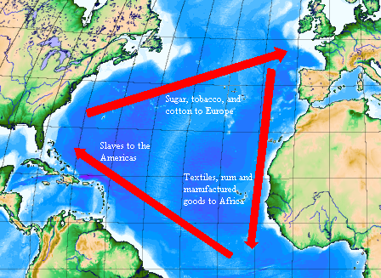
Interactive Website: http://www.eduplace.com/kids/socsci/books/applications/imaps/maps/g5s_u3/index.html

