
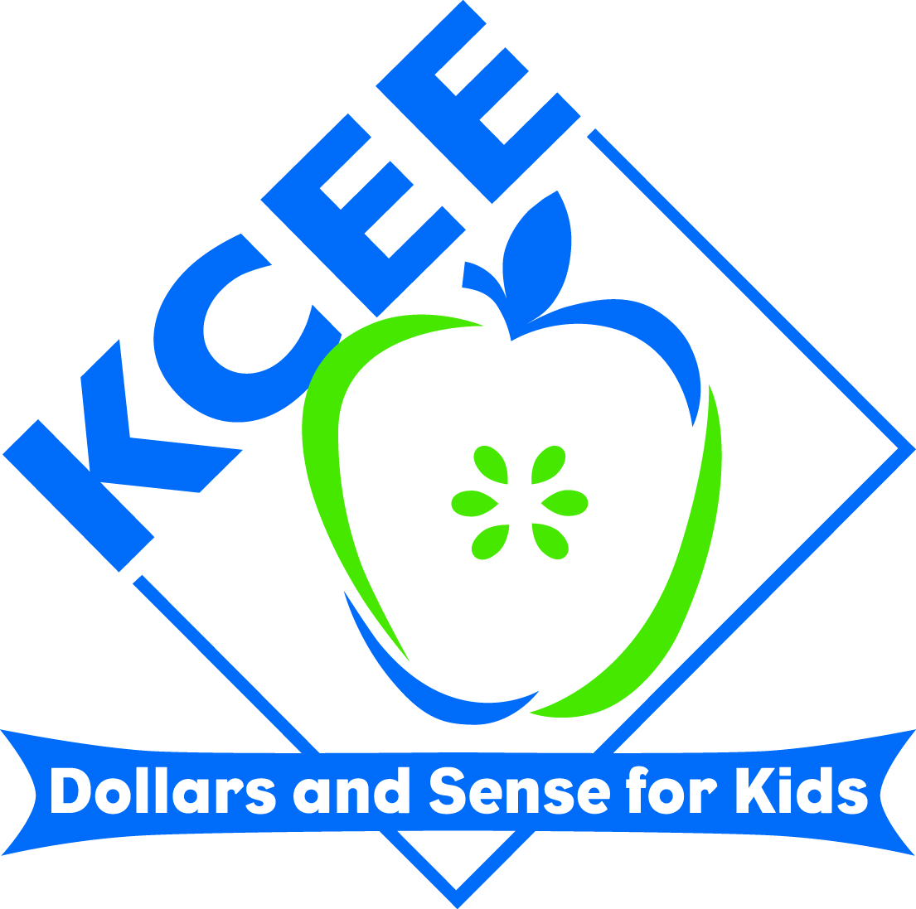
KCEE ECONOMICS/FINANCIAL LITERACY
LESSONS

Lesson Title: Understanding resources- capital, human, and natural

Subject: Social Studies

Grade Range: Grades 2-4

Name: Tonya Sandlin
Email address: tonya.sandlin@wv.kyschools.us
School District: Walton Verona Independent
School Name and Address: Walton Verona Elementary School15006 Porter Road Verona, KY 41092

Description:
- Students will understand that businesses require capital to obtain resources for their business.
- Students will understand businesses need three types of resources: human, natural, and capital resources.
- Students will identify these resources in a given situation.
- Students will understand a factory and manufacturing.

Duration: one to two 50 minute class periods

Materials:
-youtube video clip of Unwrapped TV show (Mt. Olive pickles) http://www.youtube.com/watch?v=-f_oKkNFYGw
-handout for resources (included)
-2 jars of Mt. Olive pickles (optional)

Standards:
Academic Expectations
2.18 Students understand economic principles and are able to make economic decisions that have consequences in daily living.

Primary Enduring Knowledge – Understandings
Students will understand that
• individuals, groups and businesses in the community demonstrate interdependence as they make economic decisions about the use of resources (e.g., natural, human, capital) in the production, distribution, and consumption of goods and services.
• describe and give examples of production, distribution and consumption of goods and services in the community

Academic Expectations
6.1 Students connect knowledge and experiences from different subject areas.
6.3 Students expand their understanding of existing knowledge by making connections with new
knowledge, skills and experiences.
Primary Enduring Knowledge – Understandings
Students will understand that
• technology is used in all content areas to support directed and independent learning.

Lesson/Lesson Plan:

Description:
Students will understand the following economic terms: factory, manufacture, capital, natural resource, human resource, capital resource.

Procedure:

- Begin lesson by visiting econ.org and choosing a piece of literature to whet students’ appetites for the topic. A couple of good choices to read aloud are: A Busy Day at the Factory or Agatha’s Feather Bed; Not Just Another Wild Goose Story.

- Use the literature to begin a discussion about what a business needs to begin. Introduce the vocabulary: capital, natural resources, human resources, and capital resources.

- Facilitate a discussion allowing students to contribute their ideas about these concepts. Questions to facilitate discussion: What factories are in our area? (Airhead Factory in Northern Kentucky) What natural, human, and capital resources would they need to produce their good? Do any parents work in a factory? What good do they make? What human, natural, and capital resources are needed to make this good?

- Allow students to view an Unwrapped segment (usually 3-4 minutes). A great one is Mt. Olive pickles. There are many others if you search youtube. Here is the link to the Mr. Olive episode:
http://www.youtube.com/watch?v=-f_oKkNFYGw

- After students watch the clip, have them fill in the graphic organizer (included) and list the natural, human, and capital resources.

- Include a discussion on the factory and what it means to manufacture. Discuss benefits of the manufacturing process.

- Optional: Conclude by allowing students to taste a Mt. Olive pickle if they would like. Be sure to check for allergies.

Requirements for lesson:
Handout to list the natural, human, and capital resources
Access to internet and ability to show a youtube clip
2 Jars of Mt. Olive pickles

Assessment:
Check student papers to ensure they have properly listed human, natural, and capital resources.

Name___________________________________________

List the resources you saw from the video into the correct category:

Human Natural Capital

