

KCEE ECONOMICS/FINANCIAL LITERACY
LESSONS

Lesson Title: Owning A Vehicle
Subject: Law, Personal Finance
Grade Range: 9-12
Name: Debbie Karr
Email address: debbie.karr@laurel.kyschools.us
School District: Laurel County School District
School Name and Address: North Laurel HS, 1300 Hal Rogers Pkwy, London, KY 40741

Teacher: Debbie Karr Course: Business Law
Period: 1 and 6
Date: September/February Unit: Owning a Vehicle

Learning Target (DART Statement)
- I can explain how to trade in a vehicle.
- I can explain the pros and cons of leasing a vehicle.
- I can describe the types of automobile insurance.
- I can describe the purpose of the financial responsibility law.
- I can summarize the legal aspects of repairing your vehicle.
- I can recognize federal laws designed to protect you when you buy a vehicle.

Marzano’s Strategies  X Compare/Contrast  X Vocabulary  X Summarizing/Note taking  X Reinforcing Effort/Giving Praise  - Cues, Questions, Adv Org  X Generating/Testing Hypothesis  X Homework/Practice  - Nonlinguistic Learning  X Cooperative Learning  X Setting goals/providing feedback | Formative Assessments  X Activity Sheets  - Response Boards  - On Demand Writing  X Group Work  - Student Presentation  - CPS Clicker  X Quiz  - Constructed Response  X Exit Slips  X Observation Notations  - Other | Summative Assessments  - On Demand Writing  - Student Presentation  - Constructed Response  X Unit Test  - Other

Lesson Outline
Opening Activity –See page 2
Notes and discussion
Questions
Worksheet
Test
Exit slips

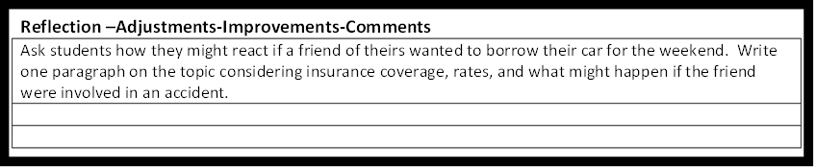

Lesson:
BUSINESS LAW
Ch. 16 Acquiring a Vehicle

Congratulations!!! You are ready to purchase a vehicle of your choice. However, you only have 20% to use for a down payment to buy a new or used vehicle or you may lease a vehicle. Decisions! Decisions! Also, you need to make several other decisions. In essence, you need to do some research on various topics before acquiring a vehicle. You may access the following sites to obtain some useful information: www.cartips.com and www.edmunds.com, carpoint.com, autosite.com, nadaguides.com, or any site that you can find the information.

HOW TO BUY NEW CARS AND AVOID SCAMS

When is the best time to buy a car? What are secret incentives?
Where can I get new car dealer invoice prices, new car rebates, and incentives?

New car buyers biggest mistake. You don’t know your credit score?

Why shouldn’t you trade in a car you own money on to buy a new car?

List 5 rude things that you the new car buyer should NEVER DO.

Should you buy a car for cash or finance it?

List a warning about new car dealer advertising.

What are online new car buying sites and how do I buy a car online?

How does a car dealer profits from your new car purchases?

TIPS FOR GETTING GOOD CAR LOANS FOR NEW CARS

List at least 4 good tips for getting good car loans for new cars?

Top 10 car dealer scams

List 4 scams

What should your credit score be for approval on new car loans?

How do you increase your car loan approval chances?

Steps to take before you apply for new car loans.

List good sources of online new car financing.

What is extended warranty? Should you buy extended warranty when buying a vehicle?

What is car leasing?

What does depreciation in a lease mean?

List 4 advantages and 4 disadvantages of leasing a vehicle?

Where and why should you shop auto insurance costs for your used car or new car?

What are some common problems with used cars?

Why should you run a vehicle history report before you buy that used car?

What is the used car lemon law?

What is a vehicle identification number? Where is it located on a car? Explain

Explain airbag fraud.

How do you tell if a used car has been flooded?

How to get a used car loan (From dealer or person to person)

How much used car loan can you afford?

Federal law requires the “buyers guide” on all dealer used card. What does that mean?

Auto warranties on used cars-What does an “as is” warranty mean?

Before you go buying new card you must get your credit report and credit score. List 3 agencies that you may receive your credit report.

What is the purpose of the federal odometer law?

What is the finance charge and APR?

