
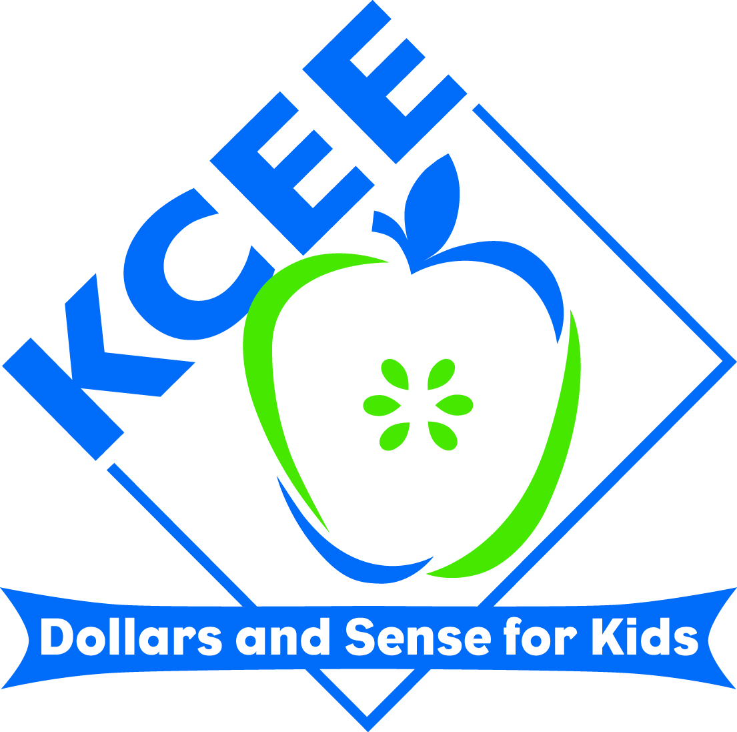
KCEE ECONOMICS/FINANCIAL LITERACY
LESSONS

Lesson Title: Monopoly “Our Way”, Learning Economics Through the Game of Monopoly

Subject: Economics

Grade Range: 5th Grade and Higher

Name: Lou Ann Boyers
Email address: louann.boyers@harrison.kyschools.us
School District: Harrison County
School Name and Address: Southside Elementary School, 106 Education Drive, Cynthiana, Kentucky 41031

Description: Students will create Monopoly® Games to review basic economic vocabulary and principles. Students will play traditional Monopoly® games to familiarize themselves with the basic premise and rules of the game. Student created games can reflect their personal interests.

Standards: Align Common Core and/or Social Studies/Economics Standards. You can also select standards for other subjects and or grade levels. (Use as much space as needed)

SS-EP-3.3.1
Students will define basic economic terms related to markets (e.g., market economy, markets, wants and needs, goods and services, profit, consumer, producer, supply and demand, barter, money, trade, advertising). DOK 2

SS-EP-3.4.1
Students will define basic economic terms related to production, distribution and consumption (e.g., goods and services, wants and needs, supply and demand, specialization, entrepreneur) and describe various ways goods and services are distributed (e.g., by price, first-come-first-served, sharing equally). DOK 2

SS-05-3.1.1
Students will describe scarcity and explain how scarcity required people in different periods in the U.S. (Colonization, Expansion, Twentieth Century to Present) to make economic choices (e.g., use of productive resources- natural, human, capital) and incur opportunity costs. DOK 2

SS-04-3.2.1
Students will explain how profit motivates individuals/businesses to take risks in producing goods and services.

SS-05-3.4.3
Students will define interdependence and give examples of how people in our communities, states, nation and world depend on each other for goods and services.

Lesson/Lesson Plan: (Use as many pages as needed.)

Materials: Poster or tag board 11” x 14” (1/4 of a regular poster board)
Post-Its® or note cards cut to 2” x 2”
Rulers
Crayons, Markers, Coloring Pencils, etc
Pencils
2 dice per game
Various game pieces (small themed toys work well)
Gallon sized plastic bags

(I supply the poster board, the Post-Its®, rulers, coloring tools, and plastic bags. Students supply their game tokens, dice – which can be borrowed from other games, and any embellishments that they want for their games.)

Day 1 – Introduce Economics Unit “I Can” statements: child friendly adaptations of the KCC for Social Studies, Economic Education. These are posted in the room and “post-it®-ed” as each standard is studies. (Marked with a removable post-it® note). Discussion of Junior Achievement activities to provide connections to prior learning is also an activity. (See Economics I Can Attachment)

Day 2 – Read Alexander Who Used To Be Rich Last Sunday, by Judith Viorst. After rich discussion, students complete Open Response Activity. (See Alexander OR Attachment)

Day 3 – Introduce Economics Core Content Vocabulary. Conduct a work session where students define the words from their own working prior knowledge, common sense inferences, and dictionary/textbook work. (See Economics Vocabulary Attachment)

Day 4 – Introduce the board game, Monopoly®, by showing the basic game board, discussing/reading rules, examining game tokens, etc. Play a mock game as a whole group – dividing into 2-4 smaller groups.

Day 5 – Introduce the concept of “themed” Monopoly® by showing some examples of some different versions of this game: Nascar®, Farm, City, ESPN®, etc. (These games can be purchased, borrowed from students or scrounged at yard sales or Goodwill!) Divide into small interest groups and play these versions of the game.

Day 6 – Introduce “Monopoly ‘Our Way’”. Explain that each student will be provided with a quarter sheet of poster board, and are going to use that to create individual Monopoly games that are themed according to their interests.

I show my model self-made games with these titles:
“Southside Monopoly”, and “Marching Band Monopoly”

Classwork will include using various school tools – rulers, pencils, markers, etc . to create the basic game board. By the end of class students should have a basic outline of the game board:
- Large corner squares
- Spaces for individual properties
- Spaces for “non improvable” properties
**These game boards will be smaller and have fewer properties than the conventional game.
>>>Homework: Decide upon a theme, and come to class prepared to begin developing your game board.
>>>Monopoly handouts, “Our Way, Tips, and Grade Report” will go home to remind students of the task, and to inform parents about the project.

Day 7 – After reviewing teacher models, student class work will consist of developing the game properties according to individual theme choices. Teacher should guide students, offer suggestions, and monitor accuracy in spelling, etc.
>>>Homework: Complete your game board

Day 8, 9, 10 – Deed Days. Students will develop Deed cards for their various properties. This takes the longest of any activity, and should be carefully monitored to help with various gaming issues. Students can use deeds from the Monopoly® sets to pattern their cards. Allow plenty of time for this.

Day 11 – Develop “Chance” cards. Students will get the handout, “Monopoly Chance” which explains the 5 cards that each student must develop for their game. These default cards are to foster an understanding of 5 basic economics vocabulary words and principles. After these cards are developed, students must complete 5 or more additional cards to make their game enticing. The “chance” cards are a combination of the Monopoly® game ideas of “Chance” and “Community Chest”. 5th Graders will combine these into one set of draw cards. The “chance” cards should be titled to match theme. For instance, my “Southside” Chance cards are “Faculty Meeting”, and my “Marching Band” Chance cards are “Directors’ Critique”. (Some students understand the humor that can occur; some are very literal, and that’s fine too!)

Day 12 – Rules & Money Day Students will write a simple set of rules for their games. I have them use the back of their game boards, for simplicity. I provide photocopied sets of Monopoly® money for students to cut out and keep in their ziplock bags with their game pieces, etc.
>>>Homework: Students should gather theme appropriate game tokens and a set of dice to play their games. (I keep extra sets of dice that students can borrow.)

Day 13– Scoring/Playing day. Students share games by playing each other’s games. Most of the time, as they play, they see some “gaming theory and practice” issues that they need to correct to make their game more playable. As students play, I use the scoring guide pages to score each student’s game.

**I offer extra credit for students who provide and decorate game boxes. Short, rectangular gift boxes work best.
**Students may provide their own stickers, cut outs, digital images, etc. to further enhance their games.

I allow 3-4 weeks for this project. My district curriculum map places economics after our winter break, so sometimes I have to modify for weather, etc. The “day” lessons are not necessarily one after the other, but merely sequences for the activities. I conduct regular Economics Core Content lessons throughout this unit. The game is the ongoing and culminating event.

I’ve had students create UK Wildcat, and other sport team Monopoly games. We’ve also had lots of Barbie®, Art,
Baby, Farm, Karate, Museum, Puppy, Kitten, Mall, etc. games. The kids are very ingenious!

