
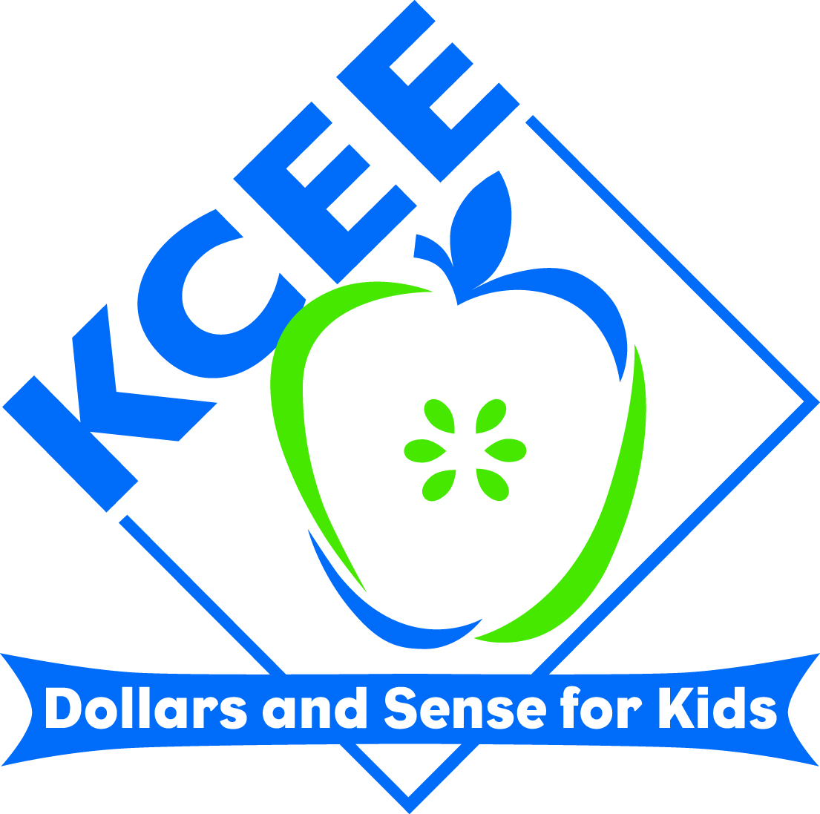
KCEE ECONOMICS/FINANCIAL LITERACY
LESSONS

Lesson Title: Dangers of Debt

Subject: Financial Literacy

Grade Range: 9th-12th

Your name: Jeremey Booher
Email address: jeremey.booher@bath.kyschools.us
School District: Bath County
School Name and Address: Bath County High School
645 Chenault Drive
Owingsville, KY 40360

Description: Most students don’t have any debt. It is very critical to mold their minds to understand that without debt, you can do some serious wealth building. It is vital that students understand that they do this and stay out of debt. This lesson allows you to give them some preventive maintenance on how to stay out of debt.
As a follow up project students will watch several short informational YouTube videos that allows them to answer questions over loans.

Learning Targets:
- I can demonstrate the various ways people get into debt.
- I can evaluate and refute the myths associated with debt.

Standards:
MA-HS-1.3.1
PL-HS-3.1.2
PL-HS-3.2.1

Lesson/Lesson Plan: (Use as many pages as needed.) If the above categories are already in your lesson, it is not necessary to put here also.

Lesson Topic/Focus: Financial Literacy – Dangers of Debt

Estimated duration of lesson:______2 – 4 days________

Procedure

Bellringer:
- For the first approximately 10 minutes of class the students will manage their stock account. Students are currently registered in http://www.virtualstockexchange.com where they have been given $10,000 to invest in the stock market with. This allows the students to infiltrate how the stock market works, how our economy works, and how usually it takes time and a lot of money (a long term investment), to make good money in the stock market. Students will also be allowed to check their email so they can get the essential question that I have emailed them. The computer is not a critical resource to this curriculum; however, we maximize the technology and inject as much collaboration as possible.
- Students will then watch Dave Ramsey’s Chapter 4 – Foundations in Personal Finance over Real Estate and Mortgages. During the video, I will pause it to ask questions and to discuss the ideas discussed.
- Students will then take a short quiz over Part 1 of the video.
- We will then discuss various ways to get ethically legal quick money (i.e. raking leaves, mowing grass, babysitting, etc.). Additionally we will compare and contrast ethically legal ways that you wouldn’t want to use to get quick money (pawn shops, pay-day loans, cash-advance loans, etc.)
- To reinforce this lesson students will answer the following questions that pertain to several short YouTube videos.

Directions: After watching the videos or reading the listed articles answer the following questions:

http://www.youtube.com/watch?v=d4TqNI9rU_s and http://www.youtube.com/watch?v=IaMGpTykul8

1. What is a Payday Loan?

____________________________________________________________________________
2. When are the balances of Payday Loans due?

____________________________________________________________________________
3. What are the typical fees and interest rates on Payday Loans?

____________________________________________________________________________
4. What happens if you can’t pay back your payday loan in the given time frame?

____________________________________________________________________________
5. Why do some people say you get “trapped” in Payday Loans?

____________________________________________________________________________
6. In your opinion, are Payday loans a good or bad way to get a loan? Please explain your answer.

____________________________________________________________________________
http://www.youtube.com/watch?v=XSj-BPV47pl

1. What is a Car Title Loan?

____________________________________________________________________________
2. What is the typical Car Title Loan amount?

____________________________________________________________________________

3. When is the balance of a Car Title Loan due?

____________________________________________________________________________
4. What happens if you can’t pay back your Car Title Loan?

____________________________________________________________________________
5. In your opinion, are Car Title Loans a good or bad way to get a loan? Please explain your answer.

____________________________________________________________________________
http://www.youtube.com/watch?v=t8SYjWVidnU

1. What does it mean to Pawn?

____________________________________________________________________________
2. When do people typically use a Pawn Shop as a loan?

____________________________________________________________________________
3. How long do you have to pay back your loan from a Pawn Shop?

____________________________________________________________________________
4. How do items end up for sale on the Pawn Shop floor?

____________________________________________________________________________
5. How does a loan from a Pawn Shop differ from getting a loan at a bank or credit union?

____________________________________________________________________________
6. In your opinion, are Pawn Shops a good or bad option for a loan? Explain your answer.

____________________________________________________________________________
http://www.moneycrashers.com/rent-to-own-stores-furniture-appliances-computers/ and http://allfinancialmatters.com/2007/03/26/renting-furniture-is-a-bad-idea/

1. What is a Rent-to-Own Centers?

____________________________________________________________________________
2. What are three things you need to watch for if using Rent-To-Own Centers?

____________________________________________________________________________
____________________________________________________________________________
____________________________________________________________________________
3. How can you make sure you are not paying too much for your items at Rent-to-Own Centers?

____________________________________________________________________________
4. In your opinion, are Rent-to-Own Centers the best way to purchase items? Explain your answer.

____________________________________________________________________________
Scoring Guide (3, 2, or 1)

Learning Targets:

- I can demonstrate the various ways people get into debt.
- I can evaluate and refute the myths associated with debt.

- The answers to these questions and the quiz will count as the students assessment for this lesson.

