


Reprintable by and only for Kentucky teachers registered for Take Stock in KY.
Take
Stock
In
Kentucky™
A program of the Kentucky Council on Economic Education

2014-15

with lessons that focus on Kentucky Program of Studies
and Core Content for Grades 4-12
Table of Contents

Take Stock in Kentucky 2

Develop Skills Across Curricula 3

Awards 4

Twelve Easy Steps to Using Take Stock in Kentucky 5

Take Stock in Kentucky Rules 8

Websites for Kentucky Research 12

Lessons and Activities 13

Lesson Correlation to Academic Expectations and Core Content 14

I. Made in Kentucky 15

2. Kentucky Producers and Service Providers 17

3. Using a Decision Tree to Make Stock Choices 18

4. Making Stock Decisions with Decision Chart 20

5. What is a Public Company? 22

6. Interdependence Web 24

7. Public Goods and Services in Your Community 26

8. Reading Stock Symbols and Data 27

8a. Stock Symbols and Data 28

8b. Stock Data Found on the Internet 29

8c. Stock Data Record 30

9. Math Activity Using Stock Data 31

Answers to Activities 8 and 9 32

10. Researching a Company 33

11. Sector/Industry Research 35

12. Is Your Stock Going Up? Or Down? 36

13. Using the News for Stock Tips 38

14. Fundamental Analysis of a Corporation 39

15. Do the Math! with Key Ratios 41

16. What are Markets? 42

17. “If It Sounds Too Good to Be True…” 44

18. Could It Be A Long Term Investment? 46

Student Journal Template 47

Culminating Activity Ideas 48

InvestWrite Essay Competition 49

Kentucky Stock List 50

TAKE STOCK IN KENTUCKY
Stock Market Game
www.econ.org/kystock
Fall Take Stock in Kentucky | 10/06/14 – 12/12/14
The Take Stock in Kentucky competition is now open to all Kentucky students. In the Take Stock in Kentucky competition, students use the same Internet simulation as the Stock Market Game, but will invest only in Kentucky companies. Teams of students will build a portfolio of Kentucky investments starting with $100,000 in imaginary funds over a period of 10 weeks. The companies they will research and invest in are headquartered in Kentucky, companies that have state offices or subsidiaries, or companies that are of special interest to the economy of Kentucky.
We have kept the list to around 200 stocks - in order for students to be able to focus on a relatively small group of companies on which to base their research. This is a great opportunity for students to learn about business in their local community and Kentucky economics.
We made it easy!! Take Stock in Kentucky was designed to for grades 4-12 to help students learn about Kentucky business and to make the program easier, because there are
1) fewer stocks to choose from,
2) ticker symbols are provided, and
3) there is a hotlink to each stock’s profile and stock data from the KCEE website.
Teachers registering for the Take Stock in Kentucky program can print out a copy of the will receive in the mail a copy of the "Take Stock in Kentucky" curriculum with 17 easy-to-use lessons focused on research of the Kentucky economy and business and on Kentucky Economics Core Content for grades 4-12, covering concepts like opportunity cost, producers, consumers, scarcity, interdependence, markets, profit, and more!
Take Stock in Kentucky is a separate competition from the Stock Market Game, with the same great prizes!!
Register online at www.stockmarketgame.org and select the dates for Take Stock in Kentucky competition.
Develop Skills Across Curricula!

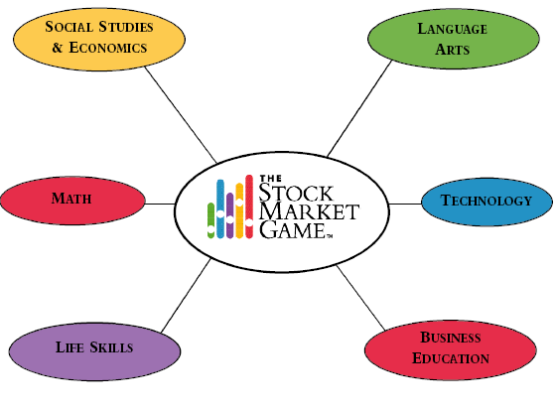
History
Geography
Government
Citizenship
Global Studies
Current Events
Graphs
Calculation
Basic Computation
Percentages
Ratios
Decimals
Estimation
Personal Finance & Budgeting
Conflict Resolution
Problem Solving
Group Decision-Making
Critical Thinking
Data Collection & Analysis
Vocabulary
Public Speaking
Journalism
Spelling
Comprehension
Reading
Research
Computer Proficiency
Internet Research
Email
Keyboarding & Data Entry
Software Applications
Simulations
Interpersonal Skills
Record Keeping
Business Organization
Financial Institutions
Marketing
Entrepreneurship
Information Processing

Have questions??? Please feel free to contact the SMG Coordinator, Susan Sandage, at susan@econ.org or 1-800-436-3266 or 502-267-3570.


Kentucky Awards & Recognitions
Kentucky SMG Awards
Each Stock Market Game and Take Stock in Kentucky session are individual competitions. (Late Spring SMG is non-competitive.)
- First Place Team winners will receive medals, certificates, and trophy for school
- Second Place Team winners will receive medals and certificates
- Third Place Team winners will receive certificates
-------------------------------------------------------------------------------------
Awards Banquet - depending on funding.
Maximum of 6 medals per team.

National Essay Competition
www. investwrite.info
Win National Prizes!
Elementary (4-5), Middle School (6-8), High School (9-12) Divisions
National awards (1st through 10th) included prizes for student, teacher, and parents! (includes laptops, gift cards, and more!) www.investwrite/info/awards.aspx

Twelve Easy Steps to Using Take Stock in Kentucky!
Using Take Stock in Kentucky, students can learn about the Kentucky economy and businesses. The program uses the same Internet simulation as the Stock Market Game, where teams of students build their own investment portfolios. As students learn, they find it exciting to compete as they build their portfolios (for the highest valued portfolio).

Step 1. Go to www.stockmarketgame.org and find answers to some of your own questions in the “Teachers New to the SMG” section. Take Stock in Kentucky uses the same Internet simulation as the Stock Market Game, with rules specific to this competition.

Step 2. Pre/Post (This is optional.) Administer the Take Stock in Kentucky pre-test before you start teaching. (Post-test students after the program is over.) You can find the pre-post test online at www.kcee.org/testing. You will receive an online report of student performance. This can help you evaluate what your students already know about investing and student learning from using the program. This is not a part of the SMG simulation, but an opportunity on the Kentucky Council on Economic Education website.

Step 3. Divide the class into teams. We recommend 3 or 4 students to a team. Each team will create an online “team portfolio” in the simulation. They will research and make stock selections as a team. Have them keep a Team Folder with their research, stock selections, essays, journals, charts, or any materials they may produce using the Stock Market Game.

Step 4. Complete the online registration form for the Stock Market Game™ program at www.stockmarketgame.org
(Follow the Register/Register Now links.)

- Be sure to select the correct dates for Take Stock in Kentucky. As you complete the online registration, this information is in the drop down box under “Game Dates”.

- At www.econ.org/smg you can make payment by credit card or print out a payment form. You will need to provide a Purchase Order#. If payment is not received within the first 3 weeks of the Game, an invoice will be sent to your bookkeeper. The fee is $15 per team of students (usually 3 to 4 per team).

- If you need more team accounts (or fewer), you can contact the SMG Coordinator (susan@econ.org) to make these adjustments within the first 2 weeks. You will be charged for all accounts you register – used or unused.
- After registering online at www.stockmarketgame.org , you will receive an email with team Account IDs and passwords. You should receive these account IDs and passwords by email within 48 hours of enrolling. If you don’t receive these in 2 or 3 days—be sure to contact Susan Sandage, SMG Coordinator, at 1-800-I-DO-ECON or susan@econ.org. (Note: account generation does not start until 3 weeks prior to the competition if you register early.)

Step 5. In the email with team IDs, you also received a Teacher ID and password to the Teacher Support Center. Use this ID and password to login @ www.stockmarketgame.org and check out the Teacher Support Center for resources, lessons, etc. to help your class get started. Introduce students to concepts like “What is a stock?” and “Buy, Sell, or Hold”. Students can use the attached Stock Data on the Internet and Stock Data Record to learn to read and track stock selections.

Step 6. Let students begin thinking and researching about stocks they may want to invest in. Have them use the Kentucky Stock List in this booklet or go to www.econ.org/kystock to view the list of Kentucky stocks (with hotlinks). This online listing has hotlinks to each companys’ profile, with stock and financial data.

Read/watch TV and discuss current events about companies, stock market performance, and the economy.

Step 7. Use lessons in this Take Stock in Kentucky booklet to learn more about Kentucky businesses, our local economy, and economic concepts.

Step 8. Make students familiar with the simulation by having them (or helping them) read through Understanding Portfolios. Visit www.stockmarketgame.org in the Teacher Support Center.

Step 9. Log-in! Assign a student team ID and password to each team and have them login to their team portfolio at www.stockmarketgame.org. (You received these IDs/passwords by email.) Students can log in before the program begins—but they cannot make a trade until the first day. It is not required for students to begin making trades on the first day of the competition—many classes begin around week 3, as teachers may be using the first few weeks to introduce concepts, how to use the simulation, etc.

Step 10. Review the Take Stock in Kentucky Rules. See short version in this booklet. Specific rules to Take Stock in Kentucky are that teams can only buy stocks on the Kentucky stock list. All other rules of the SMG simulation are the same for Take Stock in Kentucky. Remind students that this is a team competition; and that trades should be made based only on a team decision.

Step 11. Let students meet to discuss their stock buying ideas and make their first purchases. You may want to have them journal each meeting (see Journal Template in this booklet). After they’ve made their first buys, allow time each week for them to review their portfolios, rankings, and discuss more buys or sells. Students can buy/sell as often (or as little) as you want, whatever best fits your class time. Portfolios are updated every evening, as well as the Rankings, which students can access from their own portfolios.

Step 12. Focus on at least one lesson a week from the Teacher Resource Center and/or Take Stock in Kentucky booklet. When questions arise about topics, like stock splits, dividends, etc., teachers use these “teachable moments” to introduce and explain these terms and concepts.

Reinforce student creative writing and thinking skills. Take part in InvestWrite, the national essay competition. http://investwrite.info This is an individual essay competition for Stock Market Game students only, grades 4-12. Each semester a new scenario is introduced. Students write a 700 word maximum essay. Teachers can submit their 10 best essays from each class to be judged. Great prizes for elementary, middle and high school levels, in this national competition! Teachers, students, and parents can win laptops or a trip to the NYSE!!


Take Stock in Kentucky Rules
(short version!)
- Each team begins with $100,000 in cash
- All buy orders must be a minimum of 10 shares. System will not allow you to buy less than 10.
- Cannot trade stocks below $3.00/share value. You will receive a message in Transaction Notes the next day of your stock was valued less than $3.00/share.
- A 1% broker’s fee is charged for all transactions. (automatically added to all trades – buys and sells)
- Interest is earned on money not yet invested at an annual rate of .75% --posted weekly in Transaction History and added to Cash Balance.
- Teams may borrow additional funds to invest (going on margin) up to $50,000. Cost is 7% per annum.
- Teams can only invest in companies on the Take Stock in Kentucky list! Be careful, you are responsible for entering ticker symbol correct and will be disqualified if you buy a stock not on list.
- Maximum equity rule! Teams can invest no more than 20% (x2 to account for margin) of their total equity in any one stock. Simulation will not allow you to invest more than maximum equity.
Take Stock in Kentucky Rules (full version)
1. Each team begins the simulation with $100,000 in cash and may borrow additional funds. How much you may borrow is dependent upon the equity in your account. Interest is charged weekly on negative cash balances at an annual rate of 7.00%, and credited weekly on positive cash balances at an annual rate of .75%. Interest is calculated daily, then summed for the week (Sunday through Saturday) and posted on the following Tuesday. The daily rate is based upon a 365 day year. Daily Interest = Cash * Appropriate Interest Rate (as a decimal) / 365.
2. Kentucky Stock List (apply only to Take Stock in Kentucky game.)
You may trade only stocks listed on the KENTUCKY STOCK LIST. You can find this list at http://www.econ.org/kystock . You may not trade mutual funds or bonds in this competition.
This KENTUCKY STOCK LIST is list of publicly-traded companies compiled based on local newspapers regional stock listings and Hilliard Lyons Research Division. This list includes companies that are headquartered in Kentucky, companies that have state offices or subsidiaries, or companies that are of special interest to the economy of Kentucky.
If a team "accidentally" buys a stock not on this list, they can cancel that order until 4:00 pm that day on their Pending Transaction report. If a team "accidentally" buys a stock and fails to cancel the order before it goes into their portfolio -- they must sell that stock (at a loss) before the end of the competition. KCEE can not “delete” transactions made by teams-so teams are responsible for “watching” their own portfolios. Any team that has a stock other than those on the list at the end of the competition will be disqualified to win prizes.
3. - MAXIMUM EQUITY RULE Teams can invest no more than 20% (x2 to account for margin) of their total equity in any one stock. This affects both buys and short sells because both positions put their equity at risk. When placing a trade, if the requested buy or short sell is above the current 20% equity maximum, the Enter a Trade screen will give a message stating that order exceeded the maximum equity. The attempted trade, along with that message, will immediately move into the Transaction Notes report. The Maximum Equity Rule was instituted to encourage diversification in a portfolio. The SMG Program is a learning activity intended to encourage students to learn about sound investment strategies, even though the simulation is of short duration. Putting all one’s eggs in one basket is not usually sound investment practice.
4. Take Stock in Kentucky uses “end of day” pricing. End of Day Game transactions are priced at market daily closing prices. These prices can be found in the next day's newspaper or by using the price quote facilities of SMG.
5. Transactions entered with a limit price will not be held past the initial attempt to price the transaction. This applies to End of Day or Real Time Games.
6. All buy orders must be a minimum of 10 shares. Sell orders for less than 10 shares will be permitted. Held short sell positions are marked to the market daily and the resulting gain or loss is added or subtracted from cash. No mark to market transactions are posted in transaction history.
8. SMG does not permit buying stocks or mutual funds that trade below $3 per share the day before and the day of execution. Such orders will be rejected. Sell transactions for existing long positions where transactions are executed at closing or real time prices will be accepted, even if the price is less than $3.00 per share. (There are a number of reasons for this rule. Low priced stocks, known as penny stocks, are very risky and volatile investments. Accordingly, brokers will not permit their customers to trade such securities on margin, just as SMG does not. Also, penny stocks tend to have very shallow markets and their prices move sharply with large orders, unlike SMG where transactions are executed at closing or real time prices regardless of order size).
9. Trades can only be processed in whole and will be rejected if sufficient buying power does not exist to execute the entire order.
10. A 1% broker's fee is charged for all transactions. For example, if you buy 100 shares of a stock at $10 per share, you must pay the 1% of $1000 or $10. On Sell or Shortsell transactions an SEC fee is also charged. Bond buyers will also be charged for accrued interest since the last coupon date. Bond Sellers will receive the accrued interest since the last coupon date.
11. The Game is run Monday through Friday. Teams may trade on any day the participating stock markets are open. Orders may be entered 7 days a week during hours the system is available.
12. Stock trades entered after close of market (4:00 PM ET) will be priced at next day's closing price for the End of Day Game and at opening price for the Real Time Game.
13. Teams do not have to liquidate their portfolios at the end of The Game. Winners will be determined on the basis of either equity or the % return above/below S&P 500 Growth. (Some states may use additional criteria to determine winners).
Short sell/short cover rules
14. All short sell orders must be for a minimum of 10 shares. Short cover orders for less than 10 shares will be permitted. Open ended mutual funds can not be short sold.
15. SMG does not permit short sells on stocks that trade below $3.00 per share. Such orders will be rejected. Short cover transactions for existing short positions will be accepted, even if the price is less than $3.00 per share.
Portfolios
16. A record of a team's portfolio and transactions will be available daily. A team will not receive a portfolio nor be listed in regional rankings until its initial transaction is entered successfully. A student can only be assigned to ONE portfolio per game period.
17. No back posting of trades will be done for trades of securities not contained within the SMG Security Table. Once the missing security has been added to the Security Table the security can then be traded. The same rule applies to trades rejected if they are incorrectly pricing below $5. Once the pricing has been corrected the security can be traded. Only Bonds listed in the SMG can be traded. No post dating of trades due to the system being unavailable.
18. Stock and cash dividends and stock splits are automatically computed into portfolios. Every effort is made to simulate as closely to real life as possible a variety of other corporate actions (mergers, acquisitions, spinoffs, etc.), which may include the standard three-day settlement period. In this case, it may be necessary to suspend trading of a given security until the action can be completed. Canadian stocks trading on US exchanges cannot be traded between a split's record date and its payout date. It is the responsibility of teams to check their portfolios for accuracy and notify their Coordinator by email of any problems that are encountered.
19. Participants of the end of day pricing game may delete pending transactions prior to market close except bonds which are processed as real time orders.
Additional rules
20. Any violation of the rules of the SMG may result in the invalidation of a transaction. Repeated violation of the rules may result in the disqualification of a team.
21. Additional rules have been developed in some states and, if applicable, have been included in your Coordinator's Information Page. It is the responsibility of your team to learn and abide by all rules.
22. You must maintain a total equity position that is greater than or equal to 30% of the current value of your current holdings. If you don't you will receive a margin call.
Code of participation
1. SMG advisors must be responsible adults 18 years of age or older. In no case may they be a matriculated student in grades K-12.
2. SMG advisors will ensure that every participant on their team(s) has read and understands the SMG Rules and the Code of Participation.
3. Teams that do not comply with the SMG Code of Participation will be removed from the portfolio rankings.
4. The authority to remove a team from the rankings lies solely with the team's SMG coordinator organization.
5. Each team is responsible for any opening or closing transactions entered into its portfolio.
6. Teams may not enter transactions into portfolios other than their own. (Please note that when a team asserts that a transaction was entered by a non-member of that team, the team will nevertheless be ranked based on their portfolio's total equity, which will include the challenged transaction.)
7. Only transactions stored on the SMG database will be recognized for purposes of evaluating portfolio total equity.
8. SIFMA Foundation will be responsible for the accuracy of the market data. It is the responsibility of teams to report any major price discrepancies found in their portfolios. Failure to do so may result in disqualification from the competition. In extreme cases of continued disregard for this rule, SIFMA Foundation reserves the right to delete teams from the game. If a team believes a stock price or other information is incorrect, the team advisor shall notify their Coordinator by email.
Copyright © 2003 Foundation for Investor Education.
All rights reserved. Provided for educational purposes without warranty expressed or implied.

Websites for Kentucky Research
for Take Stock In Kentucky Stock Market Game

The following websites can be helpful for students using the Take Stock In Kentucky Stock Market Game program. These sites focus on Kentucky economy, businesses, and statistics.
Yahoo Finance – http://finance.yahoo.com Great for researching corporate/stock data.
MSN Money – http://moneycentral.msn.com/investor/home.asp Great for researching corporate/stock data. Try the Research Wizard or Stock Scouter!
TheStreet.com – Thestreet.com Investment education – learn about investing topics, research strategies, and more (Watch Jim Cramer video on demand!)
Think Kentucky - http://thinkKentucky.com/EDIS/Deskbook/ Kentucky Deskbook of Economic Statistics - Research and statistics on demographic and economic statistics, info on "doing business in Kentucky", existing Kentucky business and industry, and more.
KYbiz.com - http://www.kybiz.com - Find Kentucky maps, Kentucky major industry information, demographics, universities, top companies, and the Lane Report.
Courier Journal – http://www.courierjournal.com/business - Look up information about local companies, including stock data and company news, and more.
Kentucky.gov – http://Kentucky.gov/Portal/Category/FACTS Find information including facts, maps, statistics, government, and history.
Kentucky Secretary of State - http://www.kysos.com Research an online business database of over 360,000 Kentucky businesses, annual reports, etc.
Kentucky State Data Center and Kentucky Population Research - http://ksdc.louisville.edu
Map of 2003 Kentucky Metro and Micropolitan areas, Kentucky Population Projections to 2030, Worker Communing Patterns, and more.
SuperPages.com - http://wholesale.superpages.com/b2b/C-Research
Yellow pages directory for cities throughout the state.

LESSONS AND ACTIVITIES
for Take Stock In Kentucky Stock Market Game

The following activities can be helpful for teaching about Kentucky in the Take Stock in Kentucky Stock Market Game.

Teachers also have access to the Teacher Support Center in the Stock Market Game™ for more activities, lessons, and tutorials. (Use your teacher ID/password to access these resources at www.stockmarketgame.org/login.html.)

Lesson Are Aligned to Kentucky Academic Expectations and CORE CONTENT:
1. Made in Kentucky | E | M | H
2. Kentucky Producers and Service Providers | E | M
3. Using a Decision Tree To Make Stock Choices | E | M
4. Making Stock Decisions (Using a Decision-Making Model) |  | M | H
5. What is a Public Company? | E | M | H
6. Interdependence Web | E | M
7. Public Goods and Services in your Community | E | M
8. Reading Stock Symbols and Data | E | M | H
9. Math Activity Using Stock Data | E | M
10. Researching a Company | E | M | H
11. Sector/Industry Research |  | M | H
12. Is your Stock Going Up? Or Down? | E | M | H
13. Using the News for Stock Tips! |  | M | H
14. Fundamental Analysis of a Corporation | E | M | H
15. Do the Math! With Key Ratios |  | M | H
16. What are Markets? |  | M | H
17. “If It Sounds Too Good To Be True…Then It Probably Is! | E | M | H
18. Could it be a Long Term Investment? | E | M | H

E=ELEMENTARY M=MIDDLE SCHOOL H=HIGHSCHOOL
Correlation to Kentucky Academic Expectations and Core Content
in Math, Social Studies, and Practical Living (elem/ms/hs)

1. Made in Kentucky | A.E. 2.18: SS-E-3.1.1, SS-M-3.1.1,  SS-E.3.2.1, SS-M-3.4.1
2. Kentucky Producers and Service Providers | AE 2.18: SS-E-3.1.1, SS-E-3.1.2
3. Using a Decision Tree To Make Stock Choices | AE 2.18: SS-E-3.1.1, SS-E-3.1.2,  SS-E-3.1.3
4. Making Stock Decisions (Using a Decision-Making Model) | AE 2.18: SS-E-3.1.1, SS-E-3.1.2,  SS-E-3.1.3, SS-E-3.2.4, SS-E-3.4.1,  SS-M-3.2.2, SS-M-3.1.2, SS-H-3.1.1
5. What is a Public Company? | AE 2.18: SS-E-3.2.3, SS-H-3.2.2,  SS-H-3.3.4
6. Interdependence Web | AE 2.18: SS-E-3.2.1, SS-E-3.3.1
7. Public Goods and Services in your Community | AE 2.14: SS-E-1.1.1,  AE 2.18: SS-E-3.4.2
8. Reading Stock Symbols and Data | AE 2.18: SS-M-3.1.2, SS-H-3.1.3,  SS-H-3.2.3, MA-E-1.1.1, MA-E-1.1.2,  MA-E-1.1.4, MA-E-1.2.1, MA-E-1.2.9,  MA-E-1.3.1
9. Math Activity Using Stock Data | MA-E-1.1.1, MA-E-1.1.2, MA-E-1.1.4,  MA-E-1.2.1, MA-E-1.2.9, MA-E-1.3.1,  MA-E-3.2.1
10. Researching a Company | AE 2.18: SS-M-3.1.2, SS-E-3.4.1,  SS-E-3.4.3, SS-H-3.1.3
11. Sector/Industry Research | AE2.18: SS-E-3.1.1, SS-H-3.1.1,  SS-E-3.2.2, SS-E-3.2.3, SS-M-3.3.3
12. Is your Stock Going Up? Or Down? | AE 2.18: SS-E-3.3.1, SS-M-3.3.1,  SS-M-3.3.2, SS-M-3.3.3SS-E-3.2.3,  SS-E-3.2.4, SS-H-3.2.3, SS-H-3.3.1,  SS-H-3.3.3
13. Using the News for Stock Tips! | AE 2.18: SS-E-3.1.2, SS-M-3.1.1,  SS-E-3.3.1, SS-M-3.3.3, SS-H-3.3.1
14. Fundamental Analysis of a Corporation | AE 2.18: SS-E-3.2.3, SS-E-3.2.4,  SS-M-3.2.2, SS-M-3.3.2, SS-H-3.2.3,  SS-GH-3.3.2
15. Do the Math! With Key Ratios | MA-E-1.3.1, MA-E-1.4.1, MA-E-4.4.1
16. What are Markets? | AE 2.18; SS-E-3.1.1; SS-H.3.1.1;  SS-E-3.2.1, SS-M-3.2.1, SS-E-3.3.1,  SS-M-3.3.3, SS-H-3.3.1
17. “If It Sounds Too Good To Be True…Then It Probably Is! | AE 2.30: PL-E-3.1.4, PL-M-3.1.3,  PL-H-3.1.3
18. Could it Be a Good Long Term Investment? | MA-06-1.1.1, MA-07-1.1.1, MA-06-1.1.2, MA-07-1.1.2, MA-08-1.4.1 MA-HS-1.4.1, PL-HS-3.2.1

1. Made in Kentucky
Recommended for elem/middle/high
Objective: Students learn to read charts with data about their county/region and the local economy, and draw conclusions about potential for business growth.

Learn about your County/Region. Use this website to research your county (or regional) data. You will find answers to the questions under each county. http://www.thinkkentucky.com/EDIS/cmnty/

- What is the name of your county?
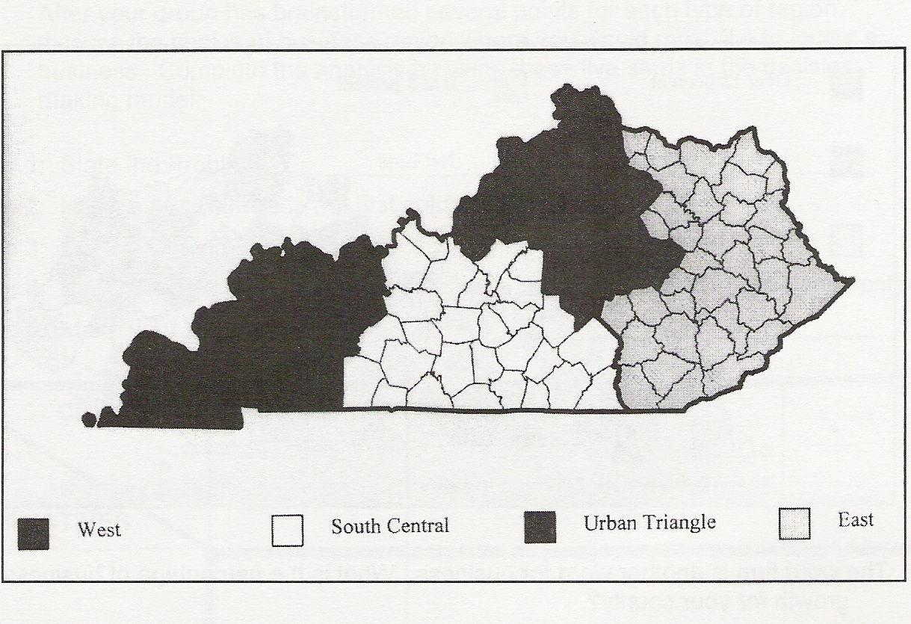

- Locate your county on the map. What region is the county in?

- Look at the data under Demographics.
What is the current population of your county?
How many more people are projected to live in your county by 2020?
- Look at the data under Workforce. Use the most recent figures.
How many workers are there in your county? (see Civilian Labor Force)

- What is the current unemployment rate for your county? What does this number mean?
- Is the unemployment rate higher or lower than in 2000?

- Are average weekly wages in your county higher or lower than the Kentucky average?

- Look under Business/Industry for data.
In which industries are most people in your region employed?
Name two of the major businesses in your region.
What do they produce or what is their service?
Which business has the most workers?

- Pretend that it is your job to talk to the owner of a national company that manufactures computer parts and sells them across the United States and in 15 countries internationally. Based on research of your county and region, write a paragraph to convince the owner to build a major manufacturing facility in your county.

Extra Credit: Using research, design an advertisement to attract a new industry or business to your town. The advertisement may be a brochure, a poster, a tri-fold, or any other creative way of advertising. Information you might include about the town: population, workforce, schools, location (possibly a map), community services, transportation routes, quality of life, cost of land, and other reasons why the business or industry would do well in the area.

2. Kentucky Producers and Service Providers

Recommended for elem/middle
Objective: Students learn about goods and services and producers in their own state.

Economic Concepts:
Goods are tangible products used by consumers to satisfy their wants and needs.
A producer is a person who makes goods and/or provides services.
Services are work or efforts that a person does for someone else.

List 4 companies from the Kentucky Stock List that are producers of goods. Name at least one of their products.
Company | Product

List 3 companies from the Kentucky Stock List that provide services. Name at least one of their services.
Company | Service

As consumers, we use goods and services to satisfy our economic wants and needs. For each of the producers of goods and services you listed above, tell which goods and/or services you or your family has probably used in the past year.


3. Using a Decision Tree
To Make Stock Choices
Recommended for elem/middle
Objective: Students learn to make wise investment decisions using a decision tree and determine their opportunity cost.

Economic Concepts:
Alternatives are options to consider when making choices.
A consumer is a person who uses goods and services to satisfy wants.
Criteria are values that are important to you.
Opportunity cost is the next best alternative that must be given up when a choice is made. Not all alternatives, just the next best.

As consumers, we use products and services everyday. Many of these products and services are from Kentucky companies. In the Take Stock In Kentucky competition, you will want to buy stock in companies that make products or provide services that people most want or need.

Your team could make your investment decisions by the dartboard method, or by tossing a coin and selecting heads or tails. Or, you can use research and the Decision Tree to help you make an educated decision.

Working individually, complete steps 1-3.

Use the Decision Tree from the next page and complete the steps.
Step 1: Define the problem or decision to be made and write it at the base of the tree.
Step 2: Select two companies from the Kentucky Stock List that you might want to invest in and find information about them on the web, TV, or in the newspaper.
Step 3: Write down the names of the two companies on your Decision Tree as your alternatives.
As a team, complete steps 4-6 for each team members’ Decision Tree.
Step 4: Discuss the good points and bad points for each company. As you discuss, you are evaluating the criteria for making your decision. Write down the good points and bad points about the companies on each team member’s Decision Tree.
Step 5: Make a decision about which one of the 2 companies your team would most like to invest in. Write the name of the company in the box at the top of the tree under the word decision.
Step 6: The company you wrote in the box is your choice for investing. What is your opportunity cost? Write it at the bottom of your Decision Tree.

Working individually again:

Step 7: Write a journal entry about this team experience using the Decision Tree. Be sure to answer all the questions. What were the reasons (criteria) you used to select this company? Is the choice made by the team, the choice you would have made? Did you think it was more difficult to make a decision as a team, than it would have been individually? Why?
3a. Decision Tree
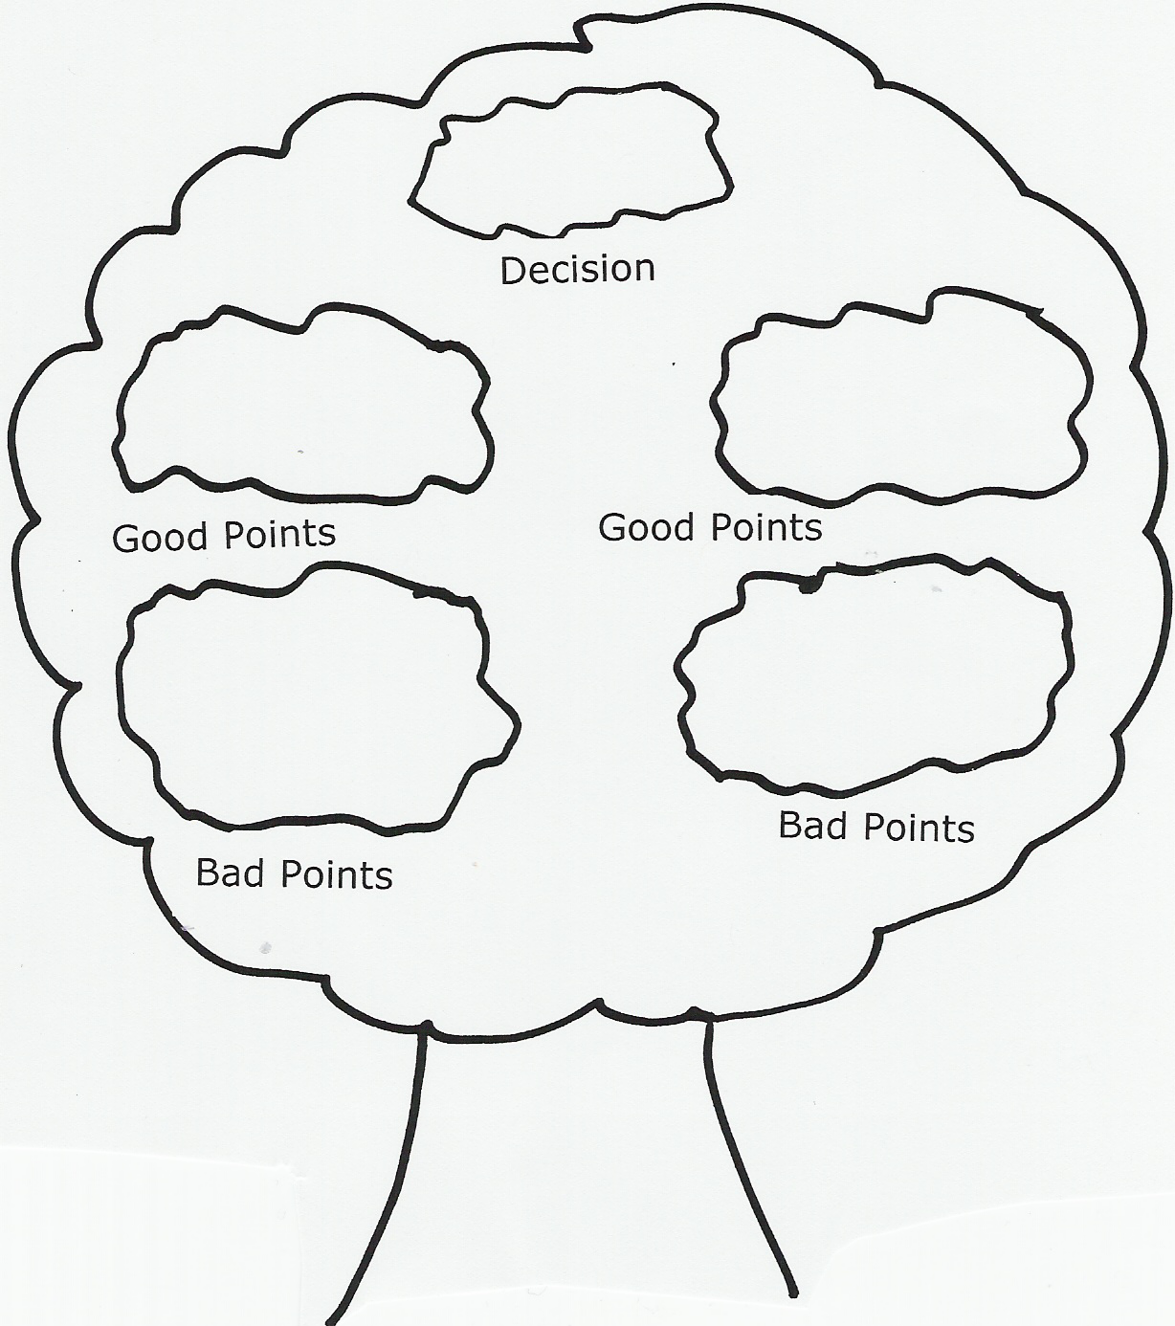

____________________
Problem
____________________ _____________________
Alternative Alternative


The company you selected to invest in, based on your criteria, is your choice – put it in the Decision circle. What is your opportunity cost?______________________

4. Making Stock Decisions
Using a Decision-Making Model

Recommended for middle/high
Objective: Students learn to use a decision-making model to evaluate criteria in making stock selections.
Economic Concepts:
A choice is what you have to make when you are faced with two or more possibilities; a decision.
Alternatives are options to consider when making a choice.
Criteria are values that are important to you.
Opportunity cost is the alternative you give up when you choose another alternative.
Scarcity is the condition of not being able to have all of the goods and services that you want.
All economic questions and problems arise from scarcity. Economics assumes people do not have the resources to satisfy all of their wants; therefore, we must make choices about how to allocate those resources. We make decisions about how to spend our money and use our time. In Take Stock in Kentucky, you will be making economic decisions about how to allocate your scarce resources (money to invest)!
______________________________________________________________
Activity:

As a team, use the Decision Making Model below to make your investment decisions. Using the Kentucky Stock List, think of popular products or services that you, your friends, or parents use every day (or would like to). Determine the company that makes these products or offers these services.

In the column under Alternatives, list 5 Kentucky companies that you think you would like to invest in. Discuss, as a team, each of the criteria for these companies. Evaluate each alternative (company) by placing a plus “+” or a minus “-“ in the box below each criteria. Make your decision for your stock selections.

4a. Decision Making Chart

Criteria  Alternatives | Popularity of  Product(s) or Service(s) | Uniqueness | Addresses or Satisfies  Needs/Wants | Is Company Socially  Responsible? | Profitability of Company

1. Using the space below, narrow your choice to two companies your team will research further to consider for your portfolio. Indicate why you selected these companies.

2. Now select one company that is your top selection. What is your choice? What is your opportunity cost?

5. What is a Public Company?
Recommended for elem/middle/high
Objective: Students learn the difference between a private and public company as they discover which companies in their community/state are publicly-held.
Companies can be divided into three types; proprietorships, partnerships and corporations. A proprietorship is a business owned by a single person. This is like Sue’s Coffee Shop. A partnership is a business owned by two or more partners. This is like Smith & Martin, Attorneys at Law. A corporation is a business that is owned by many people and acts like a single entity. This would be like Ford Motor Company. Stockholders are the owners of the corporation. They buy shares of stock issued by the corporation. Stockholders have a right to vote, sell their shares of stock, buy more stock issued by the corporation, and receive profits.
As you begin looking at Kentucky corporations, you will find many of these that you cannot invest in. Why is this?
Actually, there could be several reasons. In most cases the reason will be that the corporation is a private company rather than a public company. What is the difference?

You can broadly divide companies into two types: private and public.
Private companies are (as the name implies) privately held. A private company is one that does not issue stock to the public. Most public companies were privately owned before “going public”.
Being private means there are a smaller number of shareholders and very little information about the company has to be disclosed by the owners. Anybody can incorporate a company, all you have to do is put in some money, file the right legal documents, and follow the reporting rules of your local jurisdiction. Most all small companies are privately held, although don’t think of only small companies as private. There are many large companies that are private such as Domino’s Pizza, and Hallmark Cards.
By contrast, a public company (more accurately called publicly-owned company) is a corporation that has “gone public”, selling shares in their corporation to the public over a stock exchange, like the New York Stock Exchange (NYSE), American Stock Exchange (AMEX) or the NASDAQ market. Public companies have thousands of shareholders and are subject to strict rules and regulations. They must have a board of directors and report financial information every quarter. In the United States, public companies report information to the SEC, the Securities and Exchange Commission, a governing body that oversees public companies.
ACTIVITIES
1. Work in teams to think of companies in you community and make a list of five of these companies. Using a website, like http://finance.yahoo.com, or http://www.nyse.com and determine if these companies are publicly-held companies by doing a “ticker lookup”. (If they are publicly-held, you should be able to find the ticker symbol and which exchange the companies are listed on.)
Company Public (Y or N)
____________________________________________ _____
____________________________________________ _____
____________________________________________ _____
____________________________________________ _____
____________________________________________ _____

2. Review the Kentucky Stock list. Select 4 of these companies and determine if they are headquartered in Kentucky or another state or country. (Find their company website.)

Company Headquarters City/State
_______________________________ _________________
_______________________________ _________________
_______________________________ _________________
_______________________________ _________________

3. Name one of the companies on your list that is not headquartered in Kentucky. Why do you think this company is important to Kentucky?

4. Provide a definition for each of the underlined terms above. (Further research may be required.)

5. What are the advantages for a company to go public? What are the disadvantages?

6. Name two or more reasons why you might not be able to buy stock in a company?

6. Interdependence Web
Kentucky Business in Your Local Community

Recommended for elem/middle
Objective: Students will explore companies in their state and local community as they learn about resources the companies provide and their interdependence on other companies for their productive resources. They will discuss how technology can increase productivity.

Economic Concepts:
Economic Wants are desires that can be satisfied by consuming a good, service, or leisure activity.
Interdependence occurs when people or companies depend on someone else to provide the goods and services they consume
Productive Resources are the natural, human, and capital resources that are used to produce goods and services.
Human Resources are the people who work to produce goods and services (also called labor).
Capital Resources are goods made by people and used to produce other goods and services.
Natural Resources are “gifts of nature” that are used in the production of goods and services. The raw materials used in production come from natural resources.
To Teacher: Divide the class into teams. Divide the Kentucky Stock List into groups of 5 or more, so that each team has at least 5 companies to research.

1. Identify as many companies on the Kentucky Stock List as you can that are in your local community. You will probably not find company headquarters in your local community, but you may find offices, stores, restaurants, banks, distribution centers, etc., where the company does business locally.

2. On a map of the community, indicate the location of each business.

3. Interview parents, friends, neighbors, or community workers and determine when each business started in your community and report what you learn. How has this business affected your community?

4. Select one of the companies on your Kentucky Stock List and write a paragraph explaining how this company meets your (or your family’s) economic wants.

5. As a team, pick a company on the Kentucky stock list. Discuss the different types of technology that this company uses. Make a list of the technology tools the company uses. Does each of these tools increase productivity? Explain. Discuss how this company may have performed its business back in the early 1900s.

6a. Interdependence Web Activity

Just as consumers depend on local companies for their economic wants, local companies depend on other companies for their productive resources to produce their products or offer their services. This is called interdependence.

As a class or team project, complete the interdependence web. Select one of the companies on your list and put its name in the center circle. In each outer circle, list the name of a human, capital, or natural resources that the company may need to do business. Next to each resource, list the name of another company that may provide that resource. (It may be a local company or a company in another state or country, and not on the Kentucky Stock list.)

Interdependence Web

7. Public Goods and Services in your Community

Recommended for elem/middle
Objective: Students learn the difference between public and private goods and how taxes help pay for public goods used by citizens and businesses in the community.

Economic Concepts:
Private goods are goods and services produced privately and sold to consumers (by companies).
Public goods are goods and services provided by governments for all people to use.
Taxes are money collected by the government to pay for the goods and services it provides.

Taxes are imposed on citizens and businesses to raise monies to finance government operations and to provide the public goods and services citizens need and want. Examples of public goods and services are roads and highways, national defense, education, public transportation, law enforcement, parks and recreation, etc.

Taxes are also used to encourage or discourage certain behaviors. Cigarette and alcoholic beverage taxes are examples that discourage behavior.

There are many types of taxes collected from citizens and business to pay for these public goods, including income and payroll taxes, property taxes, sales taxes, etc.

1. Discuss in class the types of taxes that companies might pay.

2. Select a company from your Kentucky Stock List. Write a list of the public goods and services this company uses everyday.

3. Suppose your local government imposed a tax on paper used by businesses. Select a company from your Kentucky stock list. How would this tax affect this company? Do you think this tax would be good for the local economy?

8. Reading Stock Symbols and Data
Recommended for elem/middle/high
Objective: Students learn to read and interpret stock data in their newspaper and on the Internet..

Have you ever opened the newspaper, and there, right before the comics section, is a section with lots of numbers? Ever wondered why this section is in the newspaper?

These pages contain stock information that helps people keep track of their investments daily. It shows information about stocks that were traded the previous day--like the closing price, the volume, the high and low prices, etc. Learning to read this data can be an important skill for you. It can help you decide when to buy and sell stock for your portfolio. And it’s really not as difficult as it may seem.

Once you learn to read the stock data in the newspaper, you will also be able to read the data on the Internet. Look at the sample stock data on the following page and answer the following questions.

- What is the 52 week low for Stock AAZZ? _________
- What is the PE ratio for AAYY? __________
- How many shares of AAZZ traded on this day? __________
- What was the closing price for the day for AAXX stock?_________
- What is the percentage change for AAYY from the previous day?_____
- Which stock paid a dividend? _______
- What is the percentage change from low to high for AAYY? ____
- Are the symbols you will find in most newspapers the same as “Ticker” symbols you use in the Stock Market Game? _______
- Look in your local newspaper or on the Internet to find the closing prices for five companies on the Kentucky Stock list. Did any of these stocks post a dividend?

Ticker | Closing Price | Dividend?

Learning to read stock symbol data is one of the most exciting skills you will acquire from the Stock Market Game. As you learn how to read the data you will find “looking up your stocks” can be fun! You can also share your new “skill” with your parents! Show them you can read the stock pages!
8a. Stock Symbols and Data

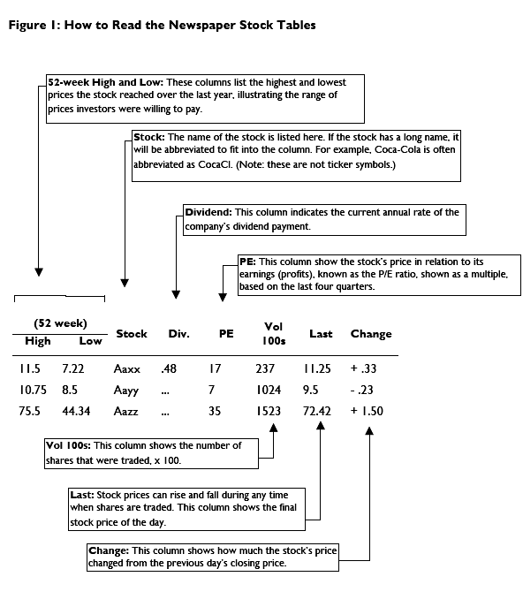

8b. Stock Data Found on the Internet
The hotlinks in Take Stock in Kentucky (http://www.econ.org/kystock are to the Finance Yahoo site. You can also try sites like, http://moneycentral.msn.com/investor/home.asp, or http://thestreet.com for research.

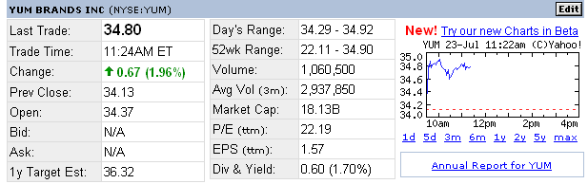

*Last Trade is the time and price of the last trade made for the stock (current price).
*Change is the change in price for the day. This is the difference between the last trade and the previous day’s closing price (Prev Close).
*Prev Close is the closing price for the trading day prior to the last trade reported.
Open is the first price paid after trading starts, usually when the stock exchange "opens its trading doors", usually in the morning.
Bid price is the price you will get if you sell your stock
Ask price is the price you will pay to buy a stock
*1y Target Est - This value is an estimated stock value in 1 year provided by analysts following this stock.
*52-Week Range – high and low prices over the past 365 days
*Volume is the volume of trading (number of shares)
Avg Vol is the Average Daily Volume which is the monthly average of the cumulative trading volume during the last 3 months divided by 22 days.
Market Cap - way of measuring the size of a company and is calculated by multiplying the current stock price by the number of outstanding shares
*P/E is Price to Earnings Ratio. This number is the previous closing stock price divided by the earnings per share, and reflects the value the market has placed on a stock. In general, a high P/E, compared to like companies, means high projected earnings in the future.
EPS is Earnings Per Share – stated for the most recent 12 months. EPS is calculated by dividing earnings by the average number of shares of common stock outstanding during the period. Analysts typically look for steadily increasing EPS.
Div is the Dividend Per Share. Annual dividend per share of stock, as reported by the company.
Yield is the annual dividend per share divided by the previous closing stock price, as a percentage (multiplied by 100).

*Students do not necessarily use all of this information in making stock selections, but some of the data can be helpful in making decisions. Fields marked with * are most commonly used.
8c. Stock Data Record
(Use this record to track your team’s portfolio investments.)
Stock Name
Ticker
RESEARCH
Date
Last Trade
Day's Range
52 Week Range
Volume
P/E
EPS
Dividend Yield
PURCHASE
Date Purchased
# Shares Purchased
Cost Per Share
Broker's Fee
Net Cost Per Share
Net Cost
SALE
Date Sold
# Shares Sold
Sale Price Per Share
Broker's Fee
Net Sale Price /Share
Net Proceeds
Net Gain/Loss
TRACKING Date | Price* | Value** | Price* | Value** | Price* | Value** | Price* | Value**
*Current value per share **Total Value
Note: "Net" value includes 1% broker's fees (commissions).

9. Math Activity Using Stock Data

Recommended for elem/middle
Objectives: Students use their math skills to interpret, calculate, and chart stock data.


Using the data provided in the “8A. Stock Data and Symbols” sheet, complete the following math problems.

1. Which stock had the greatest 52 week high?
Stock Symbol________ 52 Week High________

2. Which stock had the least volume of trading?
Stock Symbol________ Volume______________

3. List the Changes in order from least to greatest.

___________ ____________ _____________

4. What is the difference between the 52-week high and the 52-week low for Aazz?___________

5. How much higher is the PE ratio of Aazz than Aayy? _________

6. How much less is the volume of Aaxx than Aazz? __________

Use the stock prices below for the following questions.
PPJ $15.20 RBQ $35.40 ASJ $5.79 RLT $68.34

7. On the number line below, chart the stock prices for each stock.

5 10 15 20 25 30 35 40 45 50 55 60 65 70 75 80

8. Jeana has invested in these four companies: PPJ, RBQ, ASJ and RLT today, and their closing prices are listed above. She bought 100 shares of PPJ and RLT. She bought 200 shares of RBQ and ASJ. How much money did she spend on her investments today?

Answers to Activities 8 and 9

Activity 8
1. 44.34
2. 7
3. 152,300
4. 11.25
5. -.23
6. Aaxx
7. 21%
8.. No, in most newspapers the symbols are abbreviations of the company name; stock tickers are typically 1 to 4 symbols.
9. Answers may vary…

Activity 9
1. Aazz 75.5
2. Aaxx 23,700
3. -.23 +.33 +1.50
4. 31.16
5. 28
6. 128,600
7. Line Graph
8. $1,520.00 + $6,834.00 = $8,354.00
$7,080.00 + $1,158.00 = $8,238.00
$8,354.00 + $8,238.00 = $16,592.00
Bonus: If students remembered the 1% broker’s fee,
(1,520 + 30.40) + (6,834 + 136.68) +
(7,080 + 141.60) + (1,158 + 23.16) = $16,923.84.

10. Researching a Company
Recommended for elem/middle/high
Objective: Students use research skills to learn about a Kentucky company, its operations, stock value, and importance to Kentucky’s economy.

Pick a company from your Kentucky stock list for which you have a ticker symbol. Answer the following about the company and then create a timeline which tells the history of the company, its products or services, and its stock performance. (You can use the newspaper or website search engines like www.yahoo.com or http://finance.yahoo.com, or www.google.com to find information. If the company has its own website, you can type in the name of the company in the search engine to find it.)

1. What is the company name and ticker symbol? ____________________________________________________________

2. How many offices or (stores) are there in Kentucky?_________________
_______________________________________________________________

3. What products does the company make? (or services does it offer?)
_______________________________________________________________
_______________________________________________________________

4. Have you (or anyone in your family) ever used any of the products or services of the company? If yes, which ones?
________________________________________________________________
________________________________________________________________

5. What recent news is there about the company?
________________________________________________________________
________________________________________________________________
________________________________________________________________
________________________________________________________________

6. What is the company’s current stock price in today’s paper, or on the Internet? ______
What was the company’s closing stock price for last week?______ For last year?____
Can you tell anything about the company based on the change in stock price? ________________________________________________________________
________________________________________________________________

7. Based on this information, is this a company that you might be interested in adding to your Stock Market Game portfolio? Why or why not? _____________________________________________________________
_____________________________________________________________

8. What do you think are the economic reasons this company located in Kentucky?
________________________________________________________________
________________________________________________________________
________________________________________________________________

9. Find an ad (if you can) about the company’s products or services. If you can’t find one, then create your own ad for the company.

10. Create a timeline which tells the history of the company, its newsworthy events, and its stock performance. Include at least 10 events or markers on your timeline.

BONUS: Write a letter to the company to request information or to let the company know that you are researching the company (as part of the Take Stock in Kentucky program) and would like to interview a company representative.

11. Sector/Industry Research
Recommended for middle/high

Objective: Students will use research skills to group Kentucky companies into industries and compare their stock performances.

By grouping stocks into sectors and industries, it is easier for investors to evaluate stocks within the same industry and assess the economic strength or weakness of that industry. There are many different industries throughout our state.
Using your Kentucky Stock list, find one stock in each sector listed below. Provide the company name, ticker symbol, current stock price, and products/services of that company. Using the stock tables in the newspaper or on the Internet, find the 52-week range (or high/low for the year) and determine if the stock’s performance is currently up or down.

SECTOR | COMPANY NAME | TICKER | PRICE | PRODUCTS/SERVICES | Is stock  performance up  or down?
Basic Materials
Consumer, Cyclical
Consumer, Noncyclical
Energy
Financial
Healthcare
Industrial
Technology
Telecommunications
Utilities
Compare each of these stocks to a similar company (which does not need to be from the Kentucky list) in the same industry. Is this stock performing better (or worse) than the other company? Why do you think so? For more info about industry sector research, go to http://bigcharts.marketwatch.com/industry/bigcharts-com or http://finance.yahoo.com.

12. Is your Stock Going Up? Or Down?
Recommended for elem/middle/high
Objective: Students learn that different factors, like company profit, news, and the economy, can affect the demand for stock, thus affecting stock values.

Economic Concepts:
Profit –money a business has when the value of sales exceeds the cost of goods or services sold.
Demand – the various quantities (of stock) that people are able and willing to buy at different possible prices. If a lot of people want to buy a stock, the demand is up.
Supply - Supply is the amount of goods (stocks) available at a given price at any time.

What makes the price of a stock go up or down?

Profit
Companies are expected to earn profit. Profit is how much money a company makes after all the costs of the goods and services sold are paid. If you had a lemonade stand, your profit would be how much money you made after you paid for your lemons, ice, sugar, cups, helpers, etc.

If profits (earnings) increase for a company, its stock price will likely increase. Even if investors think the earnings will increase, the stock price may go up. So it is very important to know how profitable a company is and how well that company handles its finances. You can find this information in a company’s Annual Report and Quarterly Earnings Reports. You can write to a company for its annual report and find many company annual reports on the Internet—at the company’s own website.

Good News/Bad News
Good news and bad news events can also affect a company’s stock value. If good news comes out on a company, the price and the demand for the stock may go up. An example of good news might be that the company just made a new product they think will be very popular. When the news gets out, more investors will want to invest in the company, and the demand for its stock will go up (along with the price).

With bad news, the demand and the price may go down. An example of bad news for a company may be that its workers are going on strike. When the news gets out, and investors might want to sell their shares of stock in the company.

Other news can also affect a company’s stock price because it affects the stock market in general. This can include the country’s economic condition, conditions worldwide, and the stock market itself.

Supply/Demand
Stocks are subject to the same laws of supply and demand as other goods and services on the market. When there are more shares available than demand, each of those shares is worth less. The opposite is true when there is more demand than shares available.

For Discussion: Discuss other situations where the prices for goods will go up or down based on supply and demand for the goods.
12a. Is Your Stock Going Up? Or Down? Good News/Bad News Activity
Recommended for elem/middle/high
Objective: Students look at news events and draw conclusions as to whether the events will affect stock prices.
Let’s look at some good news and bad news that may affect the stock market and/or a company’s stock price. Select a company from the Kentucky Stock List. Mark how you think the news will affect your company and its stock price. Draw an arrow pointing up if you think the price will go up. Draw an arrow pointing down if you think the price will go down. Explain why.
Name and Ticker Symbol of your Company. _____________________________________
What is its product or service?_______________________________________
________________________________________________________________
Good News/Bad News | Will Stock Price Go Up or Down?
1. Your company will open 3 new plants, (or offices, or stores).
Explanation:

2. Unemployment figures for the past three months have gone up, meaning more people are out of work.
Explanation:

3. There has been an increase in demand for your company’s products (or services internationally.
Explanation:

4. The cost of gasoline drops dramatically and is expected to stay low for an extended period of time.
Explanation:

13. Using the News for Stock Tips!
Recommended for middle/high
Objective: Students read the news to research events and factors that affect Kentucky companies’ stock values.

(Use your Kentucky stock list)

- Find a national event in the newspaper that might affect a company on the Kentucky stock list. Describe what that event is and how it might affect the company. Will the event affect the company’s stock price? If so, how?

- Government actions can affect our economy as well as the stock market. There are many banks on the Kentucky stock list. Find an article about a government action that might affect a bank. Will this action affect the bank’s stock value?

- Look for an article that indicates a Kentucky company is performing well or poorly. Explain how the company’s performance might affect the company’s stock?

- Look for an upcoming event that is advertised in the newspaper. What goods or services do the event-planners need for (or as a result of) this event. What companies can provide these goods and services? Use your Kentucky stock list and find three companies that can satisfy these needs.

- Find an article about a local entrepreneur. What is his/her company name? What is the product or service being offered? As an investor, would you be able to buy stock in this company? Why, or why not?

14. Fundamental Analysis of a Corporation
Recommended for elem/middle/high
(Note: Sections A, B and C can be used by any grade level – sections D, E, F
are geared to high school students.)

Objective: Students learn to analyze a company and its financial data to evaluate its stock.

What is Fundamental Analysis? It is a method used to evaluate the worth of a security by studying the financial data of the company. It looks at the company’s income and expenses, assets and liabilities, management, and position in its industry. When you buy stock, you are becoming a part owner of a corporation. You want to know how that company handles it finances.

Let’s do our own investigation and crunch some numbers!

Selecting a Company and Obtaining Information

Choose a company from your Kentucky Stock list.

A. Gather information about the company. Using the links on the Kentucky stocks list, include the name of the company, corporate address, Kentucky office addresses, CEO, etc.

B. Obtain an annual report. One way to learn more about a company is to read its annual report. Companies are required to send a report to all shareholders informing them about how the company is doing. There can be a lot of helpful information in an annual report, and you don't have to be a shareholder to get one.
Write to the chief executive officer (CEO) to request a copy of the annual report. You can find names of CEOs and other corporate information can be found at a website like http://finance.yahoo.com, or you can find the annual report at the company website.

C. Learn About the Company from the Website and/or Annual Report.
- What are the company’s products or services?
- Who are its customers?
- Do you think the demand for the company’s products will grow?
- Why or why not?

D. Analyzing an Income Statement and Balance Sheet
Show that you can read the income statement and balance sheet by answering the following questions. Give actual figures when possible.

- What is a balance sheet?
- What is the largest asset?
- What is the largest liability?
- What is the net worth (shareholders’ equity)?
- What is an income statement?
- How much are the company’s net sales?
- What is the company’s largest cost?
- What is the profit before income taxes?
- What is the profit after income taxes (net profit)?
- What percentage of the firm’s profit is paid in income taxes?
- What are the earnings per share?
- How much of the profit was paid in dividends?
- How much of this year’s profit was retained in the company?
- How much profit has been retained in the company since it was started?

E. Analyzing Key Ratios
- Use key ratios to analyze the company. Show how you calculated each ratio.
What is the profit margin? What conclusions can you draw from this?
- What is the return on equity? What conclusions can you draw from this?
- What is the long-term debt as a percent of shareholders’ equity? What conclusions can you draw from this?
- What is the dividend yield? Is this an appropriate stock to buy for income?
- What are the earnings per share? Is the trend up or down over the last three years?
- What conclusions can you make from this trend?
- What is the price-earning ratio? Do you consider the P-E ratio good or bad? Explain.
- What is the stock’s beta? What is the industry beta?

F. Evaluating a Stock
- What are the costs and benefits of purchasing stock in this company?
- Would you buy, sell, or hold the stock?
- Would you recommend the company’s stock for income, or growth, or for both? Explain your answers in detail.
- How does this company compare to others in the same industry?
- What does the future look like for the industry and company?
- Finally, be sure to include your own observations of the company’s products and services and how the economy might have an effect on the company and/or industry.

15. Do the Math! Analyzing Key Ratios

Recommended for middle/high
Objective: Students use values and ratios to analyze stocks.

Investors using fundamental analysis often use ratios to analyze a stock’s past performance, to show a pattern or potential for growth, or to compare stocks.

Beta
Beta is a measure of how a particular stock's price moves relative to the market as a whole. It is usually described as a measure of volatility. A beta of 1 indicates that a stock's price moves exactly with the overall market. Any stock with a beta greater than 1 is more volatile than the overall market. Any stock with a beta less than 1 is less volatile than the market.

Profit Consistency
A record of consistent profits, particularly of growing profits, is desirable. Profits can be reinvested to fund further growth, and a portion can be paid to the investor in dividends.
Earnings Per Share (EPS)
This represents the company's net profit divided by the number of shares outstanding. Analysts typically look for steadily increasing EPS, which shows a pattern of consistent growth.
Price/Earnings (P/E) Ratio
This is the company's stock price divided by its 12 month EPS. In general, a high P/E means high projected earnings in the future. If a company has a PE of 10, that means that investors are willing to pay $10 for every $1 of last year's company’s earnings. It's useful to compare the PE ratios of other companies in the same industry, to the market in general, or against the company's own historical P/E ratio.
By relating price and earnings per share for a company, one can analyze the market's valuation of a company's shares relative to the income the company is actually generating. Investors can use the P/E ratio to compare the value of stocks: if one stock has a P/E twice that of another stock, all things being equal, it is a less attractive investment. Companies are rarely equal, however, and comparisons between industries, countries, and time periods may be misleading.
Dividend Yield
This is calculated by taking the amount of dividends paid per share over the course of a year and dividing by the stock’s price. Many investors need current income as represented by dividends. Stock prices go up and down, which is risky, but dividends tend to be more stable. A high yield stock pays a high dividend compared to its market price. A growth stock, where price appreciation is expected, may have a low yield or none at all. Which is riskier, a high-yield stock or a growth stock? Which offers the possibility of higher profit to an investor? Point out the trade-off of risk vs. reward. The more profit expected from an investment, the riskier it is.

Debt to Equity Ratio
The debt to equity ratio is a measure of financial strength. A lot of debt increases the risk of the shareholder. A low debt-to-equity is viewed as favorable to investors.

16. What are Markets?
Recommended for middle/high
Objective: Students learn the purpose of markets and the differences in a market economy and command economy.
Markets enable buyers and sellers to exchange goods and services. A market may be a place where buyers put their money down and carry away whatever it is they have bought--groceries from a supermarket, for example. But a market does not have to be a place. It can be something more abstract.
We can speak of "the real-estate market," for example, but it is not possible to go and look at the real-estate market; instead, the real-estate market is a complicated set of arrangements involving real-estate sales offices, property listings in newspaper ads and Web pages, for-sale signs on front lawns, even information exchanged by neighbors talking over back fences. All these arrangements help people who want to sell houses. All these arrangements, in other words, create the real-estate market.
It is the same with stock markets. In a stock market, buyers and sellers come together to exchange goods (stocks). Some stock markets, such as the New York Stock Exchange or the American Stock Exchange, do have a physical location where brokers actually make trades for people, using a computerized system. Other stock markets, such as the Nasdaq Stock Market, use computers to bring buyers and sellers together-but there is no real location – only a computer system. These markets, like the real-estate market, depend on all sorts of advertisements, newspaper and computer listings, and personal relationships that enable buyers and sellers to get together.
Markets of this sort accomplish something very important. They allocate scarce resources. The allocation occurs as a result of buyers making offers to buy and sellers deciding whether to accept the offers. When each one thinks that the proposed deal looks like a good deal, the sale is made; the homes or the stock shares in question are allocated among all the people who might possibly want them.
Allocation could be handled in other ways. For example, it could be handled by a central governing authority. A government could declare that it owned all the resources in question and that it would distribute the resources for people to use, according to some system of priorities determined by a government agency. In allocation systems of this sort, the economy is called a command economy.
Market economies differ from command economies in several important ways.
First, market economies depend upon private ownership of property. In market transactions, people sell things that are their property until ownership is transferred when someone else buys them.
Second, market economies allow people to pursue their own self-interest. Parties engage in market transactions voluntarily; each one believes he or she will benefit.
Third, market economies foster competition. Buyers won't buy unless the seller offers a deal that looks acceptable, so sellers must make an effort to provide good prices and quality.
Fourth, market economies depend upon a rule of law provided by government. The government protects private ownership of property, provides for legal enforcement of contracts, and protects people against fraud and coercion, thus enabling them to participate freely in market activity.
Fifth, market economies work efficiently and peacefully, provided that the rule of law in which they exist really is adequate to protect people from illegal practices.
People making their own decisions in an open market get only what they bargain for, and sellers in an open market have no reason to produce things that buyers don't want to buy.
Learning from the Market (NCEE)
Activities:

- Think of two other types of markets (besides stock market and real estate market) and give examples of how goods and services are exchanged. Do these markets have a “physical” location where goods or services are traded? What are the scarce resources that are allocated in these markets?

- Discuss 3 points about a market economy.

- Why is competition important in a market economy? Using the Kentucky stock list, select two companies and describe how they might compete for buyers.

17. “If It Sounds Too Good To Be True…
Then IT PROBABLY IS!!!”
Recommended for elem/middle/high
Objective: Students learn to analyze advertisements for authenticity and accuracy.

Stock Scams and Spams

“If it sounds too good to be true…then it probably is!!” You’ve probably heard this before, but what could it have to do with the stock market?

The Internet is an excellent place to research companies and stock data as there are hundreds of website that provide detailed information. As you research companies and data on the Internet, you will probably come across newsletters, e-mails, discussions, and advertisements that tout phrases, like, “hot stocks”, “risk free”, “high return”, “guaranteed”, etc. about investments you should sink your money into. Just as there are hundreds of legitimate websites that offer good data that can help you in making portfolio selections, there are thousands of promoters with promises of quick profits, that are just “...too good to be true!!”

The U.S. Securities and Exchange Commission is an agency that watches out for securities fraud and alerts investors. The following is a document for investors on their website.

- Be Alert for Telltale Signs of Online Investment Fraud
- Be wary of promises of quick profits, offers to share “inside” information, and pressure to invest before you have an opportunity to investigate.
- Be careful of promoters who use “aliases.” Pseudonyms are common on-line, and some salespeople will to try to hide their true identity. Look for other promotions by the same person.
- Words like “guarantee,” “high return,” “limited offer,” or “as safe as a C.D.” may be a red flag. No financial investment is “risk free” and a high rate of return means greater risk.
- Watch out for offshore scams and investment opportunities in other countries. When you send your money abroad, and something goes wrong, it’s more difficult to find out what happened and to locate your money.
- If a company is not registered or has not filed a “Form D” with the SEC, visit the website of the North American Securities Administrators Association to find your state securities regulator.

Find more information about Stock Scams and Frauds at the SEC website, http://www.sec.gov/investor/links/toptips.htm

Task: Find an advertisement (in an email or on the Internet) that is a promotion for a stock and discuss in class whether you would invest in that stock, or not.

If It Sounds Too Good To Be True….Activity

Be Wary of Scam Artists

Team or Individual Activity:

1. Create your own scam! Write 2 or 3 sentences as a headline (include artwork if you want) that might be used by a scam artist (someone who writes and carries out scams). The scam can be for a stock or for anything, like “How to get an A without studying!” or “Make a million $$ today—selling water!” Make sure you use words that make the offer sensational or too good to be true!

2. Once you’ve created your scam headline, pass it to another team or student to critique. The critique should be a paragraph explaining why “this is too good to be true!”

18. Could It Be a Long Term Investment?

Recommended for elementary/middle/high
Objective: Students evaluate stocks for long term versus short term investing.

Maybe your portfolio didn’t do so well, or you even lost money over the past 10 weeks! In this activity, you will look at your portfolio investments to see their past performance over the past 10 years. Go to http://www.thestreet.com
On the left, select the “click for chart” link under the DJIA (Dow Jones).

1. Currently, the DJIA is set to show a one-year chart.
Change this to a 10 year chart (1-decade) by changing the drop down box under “TimeFrame”. Select the link.

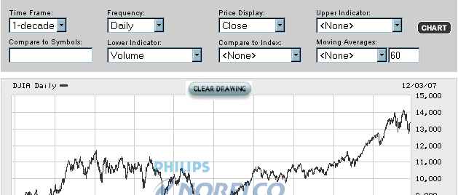

Has the DOW gone up or down over the past 10 years. _____ How many points?___________

2. Now, type in the ticker symbol for any stock in your portfolio in the box “Compare to Symbols”. How much has this stock increased in value over 10 years (or if the company has not been around for 10 years, since it began? ____________________ (this will show up as a percentage on the right side of the chart)
Ticker | Percentage + or -
3. Do the same for 3 more stocks in your portfolio. Indicate the ticker symbols and percentage increase or decrease.

4. For the 4 stocks you have charted, what is the average percentage increase/decrease of your stock values over 10 years? _________________

5. Staying invested in the stock market for the long term is a wise investment strategy. Ten years or more is usually considered long term. Would these stocks have been a good investment over the past decade? Explain.

6. What would be your advice to someone just starting to invest in the stock market for the long term?

SMG Team Journal Template Date___________

Team Name: Team Members: Class:

Purpose of Mtg.

Portfolio Value

Initial Observations

Related News Events:

Questions

Research Gathered

Decision Made and Reasons

Final Reflections
SMG Culminating Activity Ideas

Research/Writing Skills

A. Use the InvestWrite topic for critical thinking and essay writing (70 word maximum) to research a topic and relate it to a real-life experience. (InvestWrite provides new topics each semester with scenarios and a question.) www.investwrite.info

B. Use the last lesson in the online curriculum (How Successful Was My Investment Strategy?)

C. Research a company on the list back to its inception.

D. Write to a company on the list and tell about what you learned through Take Stock in Kentucky.

Oral/Presentation and Technology Skills
A. Make oral presentations:
- Why did my investment strategy not work? What would I do different next time?
- How to diversify a portfolio (using industry/sectors and or bonds, mutual funds, etc)
- How my investment strategy would be different for long-term investing.
- Research a company in portfolio and tell why it did/or didn’t’ perform well.
- Explain how the economy has had an affect on your portfolio.
- How to use an investment website to research stocks

B. Enhance oral presentations and use technology skills to create a presentation with:
- spreadsheet and charting
- graphic organizers
- PowerPoint.

Creative Skills

A. Write a skit about a broker making stock recommendations to a client.

B. Create a rap or song about a topic or a company in Take Stock in Kentucky.

Rubrics can be found in the Teacher Resource Center under “assessments” for all types of skills enhancements and presentations.

National Essay Contest
www.investWrite.info

InvestWrite is a highly successful extension of The Stock Market Game program designed to help students sharpen critical thinking and writing skills as they compose essays on investment related topics. The program builds a bridge between classroom learning and potential real-world investment decision.

Students are provided a topic and an investment scenario, which requires them to assess, research, and then formulate possible solutions based on their own finds, logic, and ideas.
How much additional time will I need to learn the InvestWrite curriculum?
Everything you need to know is on the website. Other than discussing the topics with your students and giving them a little direction, you’re done. InvestWrite is designed to enhance The Stock Market Game program without adding planning time to your current curriculum demands. Incorporate into your writing assessment
Do my students work in teams or individually?
Individually. Here’s a chance for students to take what they have learned as a member of their team and apply their critical thinking and writing skills individually.
How many essays can I submit?
You can submit ten teacher-judged entries per qualified classroom and only one essay per student.
How long does it take to submit InvestWrite entries?
Just a few minutes. All you have to do is sign in for each submission, fill in a few information boxes (i.e. your contact info, student’s name, etc.) and cut and paste or type in the InvestWrite entry into our online submission box.
Is the contest free to enter?
Absolutely! The only requirement is that you and your students must be participating in The Stock Market Game or Take Stock in Kentucky program and your class must have a valid team login ID and password.
With whom do my students compete?
Students compete nationally for prizes in their own divisions: 4-5, 6-8, or 9-12. Visit InvestWrite website for national prizes…which range from all-expense paid trips to NYSE, DisneyWorld, laptops, and gift cards for teachers, parents and students!

Kentucky Stock List – This is the list of stocks that students can invest in for the Take Stock in Kentucky competition.

In this Take Stock in Kentucky competition, students will invest in public companies that are headquartered in Kentucky, companies that have state offices or subsidiaries, or companies that are of special interest to the economy of Kentucky. We have kept this list to around 200 stocks in order for students to be able to focus on a relatively small group of stocks for their research.

As in the regular Stock Market Game, the same rules apply. The difference is that if a team "accidentally" buys a stock NOT on this list, they can cancel that order until 4:00 pm that day on their Pending Transaction report. If a team "accidentally" buys a stock and FAILS to cancel the order before it goes into their portfolio -- they must SELL that stock (at a loss) before the end of the competition. Any team that has a stock other than those on the list at the end of the competition will be disqualified to win prizes.
If you find a stock symbol that “doesn’t work”, a stock that no longer exists, or have a recommendation for this list, please contact the SMG Coordinator at susan@econ.org.

STOCK LIST WITH HOTLINKS TO
COMPANY PROFILES/STOCK DATA
can be found online at
@ http://www.econ.org/kystock

